← Mainstream Media (MSM) vs Non-MSM: Dilettantes vs Substance and the Missing “Fifth W”–WHY?
IBM AND THE NAZI HOLOCAUST →

The “Spirit” of Joseph Mengele of Auschwitz is Alive and Well in Israel: Zionism and Anti-Semitism
Posted on August 4, 2012 by jimcraven10
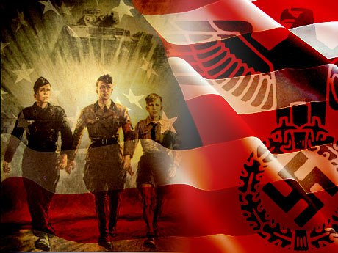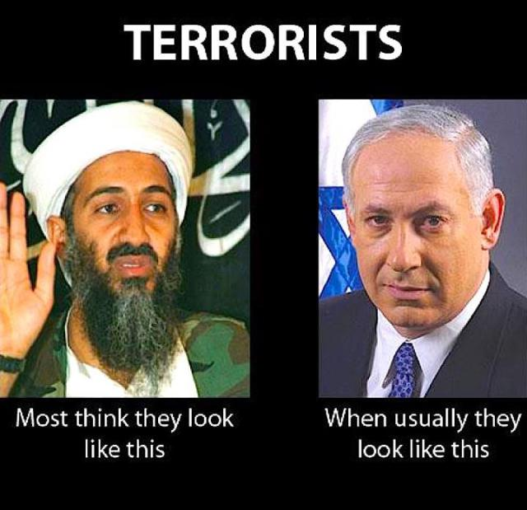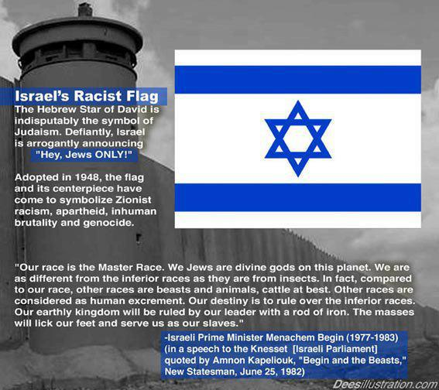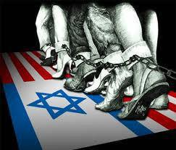
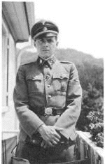
The so-called “Angel of Death” at Auschwitz, Joseph Mengele monster of human medical experimentation whose escape was aided by U.S.Army CID and CIA supposed to be looking for him under Operation Paperclip
http://jimcraven10.wordpress.com/2012/08/04/the-spirit-of-joseph-mengele-of-auschwitz-is-alive-and-well-in-israel-zionism-and-anti-semitism/

The “Spirit” of “Dr.” Josef Mengele Alive and Well in Israel
The Spirit of “Dr.” Josef Mengele Alive and Well in Israel
From: “The Other Side of Deception” by Victor Ostrovsky (former Mossad), Harper Collins, N.Y. 1994–
” That was where I would come in as a military police officer; my job was to take the prisoners to a holding facility in Nes Ziyyona, a small town south of Tel Aviv. I’d always assumed that it was an interrogation facility for the Shaback. We all knew that a prisoner brought there would probably never get out alive, but the brainwashing we’d gone through in our short lifetimes had convinced us that it was them or us; there was no gray area…
–
It was Uri who enlightened me regarding the Nes Ziyyona facility. It was, he said, an ABC warfare laboratory–ABC standing for atomic, bacteriological, and chemical. It was where our top epidemiological scientists were developing various doomsday machines. Because we were so vulnerable and would not have a second chance should there be an all-out war in which this type of weapon would be needed, there was no room for error. The Palestinian infiltrators came in handy in this regard. As human guinea pigs, they could make sure the weapons the scientists were developing worked properly and could verify how fast they worked and make them even more efficient. What scares me today, looking back at that revelation, is not the fact that it was taking place but rather the calmness and understanding with which I accepted it…
–
Years later, I met Uri again. This time he was in the Mossad, a veteran ‘katsa’ in the Al department, and I was a rookie. He had come back from an assignment in South Africa. I was then a temporary desk man in the Dardasim department in liaison helping him prepare for a large shipment of medication to South Africa to accompany several Israeli doctors who were headed for some humanitarian work in Soweto, a black township outside Johannesburg. The doctors were to assist in treating patients at an outpatient clinic for the Baragwanath hospital in Soweto, a few blocks away from the houses of Winnie Mandela and bishop Desmond Tutu. The hospital and clinic were supported by a hospital in Baltimore, which served as a cut-out for the Mossad. Uri was on a cooling-off period from the United States.
–
‘What is the Mossad doing giving humanitarian assistance to blacks in Soweto?’ I remember asking him. There was no logic to it; no short-term political gain (which was the way the Mossad operated) or any visible monetary advantage.
–
‘Do you remember Nes Ziyyona?’ His question sent shivers up my spine. I nodded.
‘ This is very much the same. We’re testing both new infectious diseases and new medication that can’t be tested on humans in Israel, for several of the Israeli medicine manufacturers. This will tell them whether they’re on the right track, saving them millions in research.’
–
‘ What do you think about all of this?’ I had to ask.
–
‘ It’s not my job to think about it.’
–(pp. 188-89)
–
The Ringworm Children: How the Israeli Government Irradiated 100,000 Israeli Kids
Israel Insider
October 28 2005
By Barry Chamish
On August 14, at 9 PM, Israel’s Channel Ten television screened a documentary film which exposes the ugliest secret of Israel’s Labor party founders: the deliberate mass radiation poisoning of nearly all Sephardi youths of a generation.
-
“The Ringworm Children” (translated in Hebrew as “100,000 Rays”), directed by David Belhassen and Asher Hemias, recently won the prize for “best documentary” at the Haifa International film festival, and in the past year has made the rounds of Jewish and Israeli film festivals around the world. But it had yet to come to Israeli television screens. The subject is the mass irradiation of hundreds of thousands of young Israeli immigrants from Middle Eastern countries — Sephardim, as they are called today. The story goes like this:
-
In 1951, the director general of the Israeli Health Ministry, Dr. Chaim Sheba, flew to America and returned with seven x-ray machines, supplied to him by the American army.
-
They were to be used in a mass atomic experiment with an entire generation of Sephardi youths to be used as guinea pigs. Every Sephardi child was to be given 35,000 times the maximum dose of x-rays through his head. For doing so, the American government paid the Israeli government 300 million Israeli liras a year. The entire Health budget was 60 million liras. The money paid by the Americans is equivalent to billions of dollars today.
-
To fool the parents of the victims, the children were taken away on “school trips” and their parents were later told the x-rays were a treatment for the scourge of scalpal ringworm. 6,000 of the children died shortly after their doses were given, while many of the rest developed cancers that killed thousands over time and are still killing them now. While living, the victims suffered from disorders such as epilepsy, amnesia, Alzheimer’s disease, chronic headaches and psychosis.
-
That is the subject of the documentary in cold terms. It is another matter to see the victims on the screen.
-
To watch the Moroccan lady describe what getting 35,000 times the dose of allowable x-rays in her head feels like. “I screamed make the headache go away. Make the headache go away. Make the headache go away. But it never went away.”
-
To watch the bearded man walk hunched down the street. “I’m in my fifties and everyone thinks I’m in my seventies. I have to stoop when I walk so I won’t fall over. They took my youth away with those x-rays.”
-
To watch the old lady who administered the doses to thousands of children: “They brought them in lines. First their heads were shaved and smeared in burning gel. Then a ball was put between their legs and the children were ordered not to drop it, so they wouldn’t move. The children weren’t protected over the rest of their bodies. There were no lead vests for them. I was told I was doing good by helping to remove ringworm. If I knew what dangers the children were facing, I would never have cooperated. Never!”
-
Because the whole body was exposed to the rays, the genetic makeup of the children was often altered, affecting the next generation. We watch the woman with the distorted face explain, “All three of my children have the same cancers my family suffered. Are you going to tell me that’s a coincidence?”
-
The majority of the victims were Moroccan because they were the most numerous of the Sephardi immigrants. The generation that was poisoned became the country’s perpetual poor and criminal class. It didn’t make sense. The Moroccans who fled to France became prosperous and highly educated. The common explanation was that France got the rich, thus smart ones. The real explanation is that every French Moroccan child didn’t have his brain cells fried with gamma rays.
-
The film made it perfectly plain that this operation was no accident. The dangers of x-rays had been known for over forty years. We read the official guidelines for x-ray treatment in 1952. The maximum dose to be given a child in Israel was .5 rad. There was no mistake made. The children were deliberately poisoned.
-
David Deri makes the point that only Sephardi children received the x-rays: “I was in class and the men came to take us on a tour. They asked our names. The Ashkenazi children were told to return to their seats. The dark children were put on the bus.”
-
The film presents a historian who first gives a potted history of the eugenics movement. In a later sound bite, he declares that the ringworm operation was a eugenics program aimed at weeding out the perceived weak strains of society. The Moroccan lady is back on the screen. “It was a Holocaust, a Sephardi Holocaust. And what I want to know is why no one stood up to stop it.”
-
David Deri, on film and then as a panel member, relates the frustration he encountered when trying to find his childhood medical records. “All I wanted to know was what they did to me. I wanted to know who authorized it. I wanted to trace the chain of command. But the Health Ministry told me my records were missing.” Boaz Lev, the Health Ministry’s spokesman chimes in: “Almost all the records were burned in a fire.”
-
We are told that a US law in the late ’40s put a stop to the human radiation experiments conducted on prisoners, the mentally feeble and the like. The American atomic program needed a new source of human lab rats and the Israeli government supplied it. Here was the government cabinet at the time of the ringworm atrocities:
-
Prime Minister – David Ben Gurion; Finance Minister – Eliezer Kaplan; Settlement Minister – Levi Eshkol; Foreign Minister – Moshe Sharrett; Health Minister – Yosef Burg; Labor Minister – Golda Meir; Police Minister – Amos Ben Gurion.
-
The highest ranking non-cabinet post belonged to the Director General of the Defence Ministry, Shimon Peres.
-
That a program involving the equivalent of billions of dollars of American government funds should be unknown to the Prime Minister of cash-strapped Israel is ridiculous. Ben Gurion had to have been in on the horrors and undoubtedly chose his son to be Police Minister in case anyone interfered with them.
-
Finance Minister Eliezer Kaplan was rewarded for eternity with a hospital named after him near Rehovot. But he’s not alone in this honor. Chaim Sheba, who ran Ringworm Incorporated, had a whole medical complex named after him. Needless to say, if there is an ounce of decency in the local medical profession, those hospital names will have to change.
-
After the film ended, there was a panel discussion which included a Moroccan singer, David Edri, head of the Compensation Committee for Ringworm X-Ray Victims, and Boaz Lev, a spokesman for the Ministry Of Health.
-
TV host Dan Margalit tried to put a better face on what he’d witnessed. He explained meekly that “the state was poor. It was a matter of day to day survival.” Then he stopped. He knew there was no excusing the atrocities which the Sephardi children endured.
-
But it was the Moroccan singer who summed up the experience best. “It’s going to hurt, but the truth has to be told. If not, the wounds will never heal.”
-
There is one person alive who knows the truth: Shimon Peres. The only way to get to the truth and start the healing is to investigate him for his role in the mass poisoning of over 100,000 Sephardi children and youth.
-
But here is why that won’t happen. The film was aired at the same time as the highest-rated TV show of the year, the finale of Israel’s talent-hunt show: “A Star Is Born.” The next day, the newly-born star’s photo took up half the front pages. There was not a word about “The Ringworm Children” in any paper, nor on the Internet. Until now.
-
Zionism and Anti-Semitism–
From Tom Segev, “The Seventh Million: Israelis and the Holocaust” Hill and Wang, NY, 1993–
” On January 31, 1933, the day after Hitler became chancellor, the independent liberal daily ‘Haaretz’ decried this ‘hugely negative historical event’. Ten days later it ran a headline that read, ‘BLACK DAYS IN GERMANY.’ The paper followed the ongoing ‘anti-Semitic horror’, but during those first weeks it, like the British press, generally aimed at reassuring its readers: ‘One must suppose that Hitlerism will now renounce terrorist methods: government brings responsibility.’ the right-wing ‘Doar Hayom’ agreed: ‘There can be no doubt that Hitler the chancellor will be different from the Hitler of the public rallies.’ But from the start, ‘Davar’–the left-wing daily published by the Histadrut (Labor Federation)–was more pessimistic: ‘It was a bitter and ill-fated day when the New Vandal came to power’, the newspaper wrote the day after the change of government in Germany. It described Hitler as a man of hate and demagoguery who would ‘tear Jews out by their roots.’ ” (p 17)
News on the Haavara Agreement
–
“More than anything else, though, the rise of the Nazis was seen as confirming the historical prognosis of Zionist ideology. ‘Hapoel Hatsair’ described the nazi persecution of the Jews as ‘punishment for their having tried to integrate into German society instead of leaving for Palestine while it was still possible to do so.’ Now they would have to run in a panic ‘like mice in flight’, the paper said. ‘The Jews of Germany are being persecuted now not despite their efforts to be part of their country but because of those efforts.’ The holocaust would later be the primary argument fro the establishment of the State of Israel and for its wars of survival.” (p. 18)
–
“Ben-Gurion hoped that the Nazis victory would become ‘a fertile force’ for Zionism.” (p. 18)
“The ‘haavara’ (‘transfer’) agreement–the Hebrew term was used in the Nazi documents as well–was based on the complementary interests of the German government and the Zionist movement: the Nazis wanted the Jews out of Germany; the Zionists wanted them to come to Palestine. But there was no such mutuality of interests between the Zionists and German Jewry. Most German Jews would have preferred to stay in their country. The tension between the interests of the ‘yishuv’ [Jewish community in Palestine] (and, in time, the State of Israel) and those of world Jewry was to become a central motif in the story of the Israelis’ attitude to the Holocaust.” (p.20)
Edwin Black on Transfer Agreement Part 1
Transfer Agreement Part 2
“The revisionist right, by contrast, had long been sympathetic to Benito Mussolini’s Fascism and now and then even to Adolf Hitler’s Naziism–except, of course, his anti-Semitism. Betar, Jabotinsky’s youth movement, fostered classic Fascist ideas and forms. In 1928, Abba Ahimeir, a well-known Revisionist journalist, had a regular column, ‘From the Notebook of a Fascist’, in the newspaper ‘Doar Hayom’. In anticipation of Jabotinsky’s arrival in Palestine, he wrote an article titled ‘On the Arrival of Our Duce’ ” (p. 23)
–
“Four years later, in early 1932, Ahimeir was among those brought to trial for disrupting a public lecvture at Hebrew University. The incident and the resulting trial are worthy of note only because of a declaration by defense attorney Zvi Eliahu Cohen in response to a speech by the prosecutor comparing the disruption of the lecture with the Nazi disturbances in Germany. ‘The comment on the Nazis’, Cohen said, ‘went too far. Were it not for Hitler’s anti-Semitism, we would not oppose his ideology. Hitler saved Germany.’ This was not an unconsidered outburst; the Revisionist paper ‘Hazit Haam’ praised Cohen’s ‘brilliant speech.’ ” (p. 23)
–
“…[from Hazit Haam] ‘Social Democrats of all stripes believe that Hitler’s movement is an empty shell.’, the newspaper explained, but ‘we believe that there is both a shell and a kernel. The anti-Semitic shell is to be discarded, but not the anti-Marxist kernel. The Revisionists, the newspaper wrote, would fight the Nazis only to the extent that they were anti-Semites.” (p. 23)
–
“The haavara agreement was a central issue in the elections in the summer of 1933 for representatives to the Eighteenth Zionist Congress. The Revisionists rejected [in a turnabout] any contact with Nazi Germany. It was inconsistent with the honor of the Jewish people, they said; Jabotinsky declared it ‘ignoble, disgraceful and contemptible’. The Revisionist press now castigated the Zionist Organization and the Jewish Agency as ‘Hitler’s allies’, people ‘who have trampled roughshod on Jewish honor, on Jewish conscience, and on Jewish ethics…dark characters who have come to trade on the troubles of the Jews and on the land of Israel…low types who have accepted the role of Hitler’s agents in Palestine and in the entire Near East…traitors…deceivers who lust after Hitler’s government.’ ” (p. 24)
Transfer Agreement Part 3
–
“After reading the Nazi Party newspaper, Ben-Gurion wrote, it seemed to him that he was reading the words of Zeev Jabotinsky in Doar Hayom: ‘the same thing, the same style, and the same spirit.’ ” (p. 24)
–
“In his impassioned speech, Ben-Gurion called for the rescue of German Jewry, ‘a tribe of Israel’, and their transfer to Palestine, rather than action against Hitler. ‘ I do not believe that we can oust him and I am not interested in anything other than saving these 500,000 Jews,’ he said. Ben-Gurion saw the debate between rescue and boycott as a debate between Zionism and assimilation, between the nationalist interests of Jewish settlement in Palestine and the international war against anti-Semitism. The assumption imnplicit in his words was that the war against anti-Semitism was not a part of the Zionist mission.” (pp. 24-25)
–
“To make his point, Ben-Gurion used harsh language that would in time be employed by anti-Zionists: ‘If I knew that it was possible to save all the children in Germany by transporting them to England, but only half of them by transporting them to Palestine, I would choose the second–because we face not only the reckoning of those children, but the historical reckoning of the Jewish people.’ In the wake of the Kristallnacht pogroms, Ben-Gurion commented that the ‘human conscience’ might bring various countries to open their doors to Jewish refugees from Germany. He saw this as a threat and warned: ‘Zionism is in danger.’ ” (p 28)
–
“Nevertheless, the pragmatists were convinced that the boycott of Germany could not advance the interests of Palestine, that their ends could best be accomplished through contact with the Nazis. Thus the leaders sought to keep relations with Nazi Germany as normal as possible: Two months after Hitler came to power the Jewish Agency executive in Jerusalem had sent a telegram straight to the Fuhrer in Berlin, assuring him that the yishuv had not declared a boycott against his country; the telegram was sent at the request of German Jewry in the hope of halting their persecution, but it reflected the Jewish Agency’s inclination to maintain correct relations with the Nazi Government. Many years later, Menachem Begin revealed that the Zionist Organization had sent hitler a cable of condolence on the death of President Hindenburg.” (p. 29)
Transfer Agreement Part 4
Transfer Agreement Part 5
“Traveling on to Cairo, he [Eichmann] summoned a Jew from Jerusalem, one Fiebl Folkes. A report from Eichmann wrote of his trip and the record of his interrogation by the Israeli police decades later indicate[s] that Folkes was a member of the Haganah–the clandestine Jewish defense force–and a Nazi agent. On one occasion he even met with Eichmann in Berlin. The Nazis paid him for his information, mostly rather general political and economic evaluations. Among other things, Eichmann quoted Folkes to the effect that Zionist leaders were pleased by the persecution of German Jewry, since it would encourage immigration to Palestine.” (p. 30)
–
“Ironically the Revisionists also had fairly wide-ranging links with the Nazis. The Betar youth movement was active in Berlin and several other German cities. About half a year before the Nazis came to power, the movement’s leadership distributed a memorandum to its members that was both commonsensical and cautious. The Nazis should be treated politely and with reserve, the memorandum instructed. Whenever Betar members were in public, they should remain quiet and refrain from vocal debates and critical comments. Under no circumstances should anyone say anything that could be interpreted as an insult to the German people, to its institutions, or to its prevailing ideology.
–
The Nazis allowed Betar to continue its activities–meetings, conventions, summer camps hikes, sports, sailing, and agricultural training. Members were allowed to wear their uniforms, which included brown shirts, and they were allowed to publish mimeographed pamphlets, including Zionist articles in a nationalistic, para-Fascist tone, in the spirit of the times. The German Betar pamphlets focused on events in Palestine, and their exuberant nationalism targeted the British, the Arabs, and the Zionist left. The contained no references to the political situation in Germany. With this exception, they were similar to the nationalist German youth publications, including those published by the Nazis. Jabotinsky decried the influence Hitlerism was having on the members of Betar.” (pp. 32)
–
“In the second half of 1940, a few members of the Irgun Zvai Leumi (National Military Organization)–the anti-British terrorist group sponsored by the Revisionists and known by its acronym Etzel, and to the British simply as the Irgun–made contact with representatives of Fascist Italy, offering to cooperate against the British. Soon the Etzel split, and the group headed by Avraham “Yair” Stern formed itself into the Lehi (from the initials of its Hebrew name, Lohamei Herut Yisrael–Fighters for the Freedom of Israel), also known as the Stern Gang. A representative of this group met with a German foreign ministry official and offered to help Nazi Germany in its war against the British. The Germans understood that the group aimed to establish an independent state based on the totalitarian principles of the Fascist and Nazi regimes. Many years after he tried to forge this lik with Nazis, a former Lehi leader explained what had guided his men at the time: ‘Our obligation was to fight the enemy. We were justified in taking aid from the Nazi oppressor, who was in this case the enemy of our enemy–the British.’ ” (p. 33)
–
“The question was what to do with those refugees who were neither Zionist nor fit to help build the new society in Palestine. ‘Only God knows how the poor little land of Israel can take in this stream of people and emerge with a healthy social structure’, Chaim Weizmann wrote. The German Immigrants Association complained that the Jewish Agency’s representatives in Berlin were giving immigration certificates to invalids. ‘ The human material [direct quote and their words] coming from Germany is getting worse and worse’, the association charged after almost a year of Nazi rule. ‘They are not able and not willing to work, and they need social assistance.’ A year later the association sent to Berlin a list of names of people who should not have been sent. Henrietta Szold, who headed the Jewish Agency’s social-work division, also frequently protested about the sick and needy among the immigrants. From time to time Szold demanded that certain of such ‘cases’ be returned to Nazi Germany so that they would not be a burden on the yishuv.” (p. 43)
–
“In 1937 the Joint Distribution Committee, an American organization that assisted needy Jews, negotiated with the German authorities for the release of 120 Jewish prisoners from the Dachau concentration camp. ‘I am not so sure that from a political point of view it is desirable that all those released come to Palestine’, a Jewish Agency official wrote to one of his colleagues. Most were not Zionists; and there may even have been Communists among them.” (pp 43-44)
–
“Senator [Werner Senator of the Jewish Agency] who was active in bringing German Jews to Palestine, warned the Jewish Agency office in Berlin that if it did not improve the quality of the ‘human material’ it was sending, the agency was liable to cut back the number of certificates set aside for the German capital. The immigrants from Germany enjoyed all sorts of special benefits, Senator wrote. They received immigration certificates after only six months of agricultural training, while in other countries up to two years was required. Requests for family reunification from Germans with relatives in Palestine were also quickly approved. All this required special attention to the quality of immigrants, who should be true pioneers. Senator was not referring to occasional errors in judgment, he assured his colleagues; he was talking about a trend. More and more ‘ welfare cases’ were arriving from Germany, as well as too many ‘businessmen with children’ rather than single men and women. At one point it was decided that candidates above the age of thirty-five would receive immigration certificates ‘only if there is no reason to believe that they might become a burden here.’ Accordingly they had to have a profession. ‘Anyone who was a merchant’, the decision stated, or of similar employment, will not receive a certificate under any circumstances, except in the case of veteran Zionists.’ This was in 1935. ‘ In days of plenty, it was possible to handle this material [emphasis added]‘ , explained Yitzhak Gruenbaum. ‘In days of shortages and unemployment, this material [emphasis added] will cause us many problems…We must be allowed to choose from among the refugees those worthy of immigration and not accept them all.’ ” (p. 44)
Footnote: “In 1939 the world press followed the drama of the St Louis, a boat carrying several hundred Jewish refugees from Germany. No country would give them asylum. The Joint Distribution Committee asked the Jewish Agency to allot the passengers several hundred immigration certificates from the quota. The Jewish Agency refused. In the end the refugees were allowed into Antwerp. [note where many were exterminated after the takeover of Belgium by the Nazis.]. (p. 44)
–
” German Jews who were given immigration permits ‘merely as refugees’ were also considered ‘undesirable human material’ by Eliahu Dobkin, a Mapai member of the Jewish Agency executive. ‘I understand very well the special situation in which the overseas institutions dealing with German refugees find themselves, but I would like to believe that you would agree with me that we must approach this question not from a philanthropic point of view but from the point of view of the country’s needs’, Dobkin wrote to one of his colleagues. ‘My opinion is that from among the refugees we must bring only those who meet this condition.’ Leaders of the German immigrants agreed. ‘As I see it, 90 percent of them are not indispensible here’, one of them wrote to another.” (pp 44-45)
–
“It was an incomparably cruel reality: every Jew who received an immigration certificate during those years lived in Palestine knowing that some other Jew who had not received that certificate had been murdered. This was the basis for the sense of guilt that would later trouble so many Israelis who escaped the Holocaust.” (p 45)
From Zionism in the Age of the Dictators by Lenni Brenner:
–
In June of 1895, the first entry into his new journal on Zionism, Theodor Hertzl wrote:
“In Paris, as I have said, I achieved a freer attitude toward anti-Semitism, which I now began to understand historically and to pardon. Above all, I recognized the emptiness and futility of trying to ‘combat’ anti-Semitism.”
–
To be a Good Zionist one must be Somewhat of an Anti-Semite:
Although blut was a recurrent theme in pre-Holocaust Zionist literature, it was not as central to its message as boden. As long as America’s shores remained open, Europe’s Jews asked: if anti-Semitism could not be fought on its home ground, why should they not just follow the crowd to America? The Zionist response was double-barrelled: anti-Semitism would accompany the Jews wherever they went and, what was more, it was the Jews who had created anti-Semitism by their own characteristics. The root cause of anti-Semitism, Zionists insisted, was the Jews’ exile existence. Jews lived parasitically off their ‘hosts’…
–
These tenets combined were known as ‘shelilat ha’galut (the Negation of the Diaspora), and were held by the entire spectrum of Zionists who varied only on matters of detail. They were argued vigorously in the Zionist press, where the distinctive quality of many articles was their hostility to the entire Jewish people. Anyone reading these pieces without knowing their source would have automatically assumed that they came from the Anti-Semitic press. The Weltanschauung of the youth organization Hashomer Hatzair (Young Watchmen), originally composed in 1917, but republished again as late as 1936, was typical of these effusions: The Jew is a caricature of a normal, natural human being, both pysically and spiritually. As an individual in society he revolts and throws off the harness of social obligations, knows no order nor discipline. (pp. 22-23)
–
Similarly, in 1935 an American Ben Frommer, a writer for the ultra-right Zionist-Revisionists, could declare of no less than 16 million of his fellow Jews that:
The fact is undeniable that the Jews collectively are unhealthy and neurotic. Those professional Jews who, wounded to the quick, igdignantly deny this truth are the greatest enemies of their race, for they thereby lead them to search for false solutions, or at most palliatives.” (p. 23)
–
And:
In 1925 the most vehement protagonist of total abstentionism, Jcob Klatzkin, the co-editor of the massive “Encyclopedia Judaica”, laid down the full implications of the Zionist approach to anti-Semitism:
“If we do not admit the rightfulness of antisemitism, we deny the rightfulness of our own nationalism. If our people is deserving and willing to live its own national life, then it is an alien body thrust into the nations among whom it lives, an alien body that insists on its own distinctive identity, reducing the domain of their life. It is right therefore, that they should fight against us for their national integrity…Instead of establishing societies for defense against antisemites, who want to reduce our rights, we should establish societies for defense against our friends who desire to defend our rights.” (p. 30)
Books from Lenni Brenner for download free:
The Iron Wall: http://vho.org/aaargh/fran/livres3/Ironw.pdf
Zionism in the Ageof the Dictators

