Citibank Plutonomy Report: Original
August 23, 2010
Reposted from http://www.scribd.com/doc/6674234/Citigroup-Oct-16-2005-Plutonomy-Report-Part-1, originally brought to my attention via Capitalism: A love story . If you have a short attention span or want to know why I posted this here, see my edited version Citibank Plutonomy Report: Essay on income inequality version.

Citigroup Equity Strategy
Plutonomy: Buying Luxury, Explaining Global Imbalances
October 16, 2005

Summary
- The World is dividing into two blocs – the Plutonomy and the rest. The U.S., UK, and Canada are the key Plutonomies – economies powered by the wealthy. Continental Europe (ex-Italy) and Japan are in the egalitarian bloc.
- Equity risk premium embedded in “global imbalances” are unwarranted. In plutonomies the rich absorb a disproportionate chunk of the economy and have a massive impact on reported aggregate numbers like savings rates, current
account deficits, consumption levels, etc. This imbalance in inequality expresses itself in the standard scary ” global imbalances”. We worry less.
- There is no “average consumer” in a Plutonomy. Consensus analyses focusing on the “average” consumer are flawed from the start. The Plutonomy Stock Basket outperformed MSCI AC World by 6.8% per year since 1985. Does even better if equities beat housing. Select names: Julius Baer, Bulgari, Richemont, Kuoni, and Toll Brothers.

WELCOME TO THE PLUTONOMY MACHINE
In early September we wrote about the (ir)relevance of oil to equities and introduced the idea that the U.S. is a Plutonomy – a concept that generated great interest from our clients. As global strategists, this got us thinking about how to buy stocks based on this plutonomy thesis, and the subsequent thesis that it will gather strength and amass breadth. In researching this idea on a global level and looking for stock ideas we also chanced upon some interesting big picture implications. This process manifested itself with our own provocative thesis: that the so called “global imbalances” that worry so many of our equity clients who may subsequently put a lower multiple on equities due to these imbalances, is not as dangerous and hostile as one might think. Our economics team led by Lewis Alexander researches and writes about these issues regularly and they are the experts. But as we went about our business of finding stock ideas for our clients, we thought it important to highlight this provocative macro thesis that emerged, and if correct, could have major implications in terms of how equity investors assess the risk embedded in equity markets. Sometimes kicking the tires can tell you a lot about the car-business.
Well, here goes. Little of this note should tally with conventional thinking. Indeed, traditional thinking is likely to have issues with most of it. We will posit that:
1) the world is dividing into two blocs – the plutonomies, where economic growth is powered by and largely consumed by the wealthy few, and the rest. Plutonomies have occurred before in sixteenth century Spain, in seventeenth century Holland, the Gilded Age and the Roaring Twenties in the U.S. What are the common drivers of Plutonomy? Disruptive technology-driven productivity gains, creative financial innovation, capitalist friendly cooperative governments, an international dimension of immigrants and overseas conquests invigorating wealth creation, the rule of law, and patenting inventions. Often these wealth waves involve great complexity, exploited best by the rich and educated of the time.
2) We project that the plutonomies (the U.S., UK, and Canada) will likely see even more income inequality, disproportionately feeding off a further rise in the profit share in their economies, capitalist-friendly governments, more technology-driven productivity, and globalization.
3) Most “Global Imbalances” (high current account deficits and low savings rates, high consumer debt levels in the Anglo-Saxon world, etc) that continue to (unprofitably) pre- occupy the world’s intelligentsia look a lot less threatening when examined through the prism of plutonomy. The risk premium on equities that might derive from the dyspeptic “global imbalance” school is unwarranted – the earth is not going to be shaken off its axis, and sucked into the cosmos by these “imbalances”. The earth is being held up by the muscular arms of its entrepreneur-plutocrats, like it, or not.
Fixing these “global imbalances” that many pundits fret about requires time travel to change relative fertility rates in the U.S. versus Japan and Continental Europe. Why? There is compelling evidence that a key driver of current account imbalances is demographic differences between regions. Clearly, this is tough. Or, it would require making the income distribution in the Anglo-Saxon plutonomies (the U.S., UK, and Canada) less skewed to the rich, and relatively egalitarian Europe and Japan to suddenly embrace income inequality. Both moves would involve revolutionary tectonic shifts in politics and society. Note that we have not taken recourse to the conventional curatives of global rebalance – the dollar needs to drop, either abruptly, or smoothly, the Chinese need to revalue, the Europeans/Japanese need to pump domestic demand, etc. These have merit, but, in our opinion, miss the key driver of imbalances – the select plutonomy of a few nations, the equality of others. Indeed, it is the “unequal inequality”, or the imbalances in inequality across nations that corresponds with the “global imbalances” that so worry some of the smartest people we know.
4) In a plutonomy there is no such animal as “the U.S. consumer” or “the UK consumer”, or indeed the “Russian consumer”. There are rich consumers, few in number, but disproportionate in the gigantic slice of income and consumption they take. There are the rest, the “non-rich”, the multitudinous many, but only accounting for surprisingly small bites of the national pie. Consensus analyses that do not tease out the profound impact of the plutonomy on spending power, debt loads, savings rates (and hence current account deficits), oil price impacts etc, i.e., focus on the “average” consumer are flawed from the start. It is easy to drown in a lake with an average depth of 4 feet, if one steps into its deeper extremes. Since consumption accounts for 65% of the world economy, and consumer staples and discretionary sectors for 19.8% of the MSCI AC World Index, understanding how the plutonomy impacts consumption is key for equity market participants.
5) Since we think the plutonomy is here, is going to get stronger, its membership swelling from globalized enclaves in the emerging world, we think a “plutonomy basket” of stocks should continue do well. These toys for the wealthy have pricing power, and staying power. They are Giffen goods, more desirable and demanded the more expensive they are.

RIDING THE GRAVY TRAIN – WHERE ARE THE PLUTONOMIES?
The U.S., UK, and Canada are world leaders in plutonomy. (While data quality in this field can be dated in emerging markets, and less than ideal in developed markets, we have done our best to source information from the most reliable and credible government and academic sources. There is an extensive bibliography at the end of this note). Countries and regions that are not plutonomies: Scandinavia, France, Germany, other continental Europe (except Italy), and Japan.

THE UNITED STATES PLUTONOMY – THE GILDED AGE, THE ROARING TWENTIES, AND THE NEW MANAGERIAL ARISTOCRACY
Let’s dive into some of the details. As Figure 1 shows the top 1% of households in the U.S., (about 1 million households) accounted for about 20% of overall U.S. income in 2000, slightly smaller than the share of income of the bottom 60% of households put together. That’s about 1 million households compared with 60 million households, both with similar slices of the income pie! Clearly, the analysis of the top 1% of U.S. households is paramount. The usual analysis of the “average” U.S. consumer is flawed from the start. To continue with the U.S., the top 1% of households also account for 33% of net worth, greater than the bottom 90% of households put together. It gets better (or worse, depending on your political stripe) – the top 1% of households account for 40% of financial net worth, more than the bottom 95% of households put together. This is data for 2000, from the Survey of Consumer Finances (and adjusted by academic Edward Wolff). Since 2000 was the peak year in equities, and the top 1% of households have a lot more equities in their net worth than the rest of the population who tend to have more real estate, these data might exaggerate the U.S. plutonomy a wee bit.
Was the U.S. always a plutonomy – powered by the wealthy, who aggrandized larger chunks of the economy to themselves? Not really. For those interested in the details, we recommend “Wealth and Democracy: A Political History of the American Rich” by Kevin Phillips, Broadway Books, 2002.

Figure 1. Characterizing the U.S. Plutonomy: Based on the Consumer Finance Survey, the Top 1% Accounted For 20% of Income, 40% of Financial Wealth and 33% of Net Worth in the U.S. (More Than the Net Worth of the Bottom 95% Households Put Together) in 2001
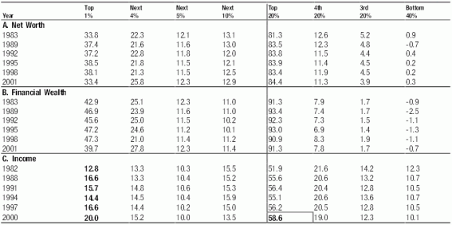
Source: Table 2 from Edward Wolff (please see reference 26 in the bibliography at the end of the report). Computations done by Prof. Wolff from the 1983, 1989, 1992, 1995, 1998, and 2001 Surveys of Consumer Finances. For the computation of percentile shares of net worth, households are ranked according to their net worth; for percentile shares of financial wealth, households are ranked according to their financial wealth; and for percentile shares of income, households are ranked according to their income. Net worth in Prof Wolff’s calculation is the difference in value between total assets and total liabilities or debt. Total assets are defined as the sum of: (1) the gross value of owner-occupied housing; (2) other real estate owned by the household; (3) cash and demand deposits; (4) time and savings deposits, certificates of deposit, and money market accounts; (5) government bonds, corporate bonds, foreign bonds, and other financial securities; (6) the cash surrender value of life insurance plans; (7) the cash surrender value of pension plans, including IRAs, Keogh, and 401(k) plans; (8) corporate stock and mutual funds; (9) net equity in unincorporated businesses; and (10) equity in trust funds. Total liabilities are the sum of: (1) mortgage debt, (2) consumer debt, including auto loans, and (3) other debt. Prof Wolff defines Financial wealth as net worth minus net equity in owner-occupied housing. Financial wealth is a more “liquid” concept than marketable wealth, since one’s home is difficult to convert into cash in the short term.

Figure 2. The Income Share of the Top 0.1% of U.S. Households Has Risen from Under 2% in the Early 1970s to Over 7% in 2000, Based on Tax Data
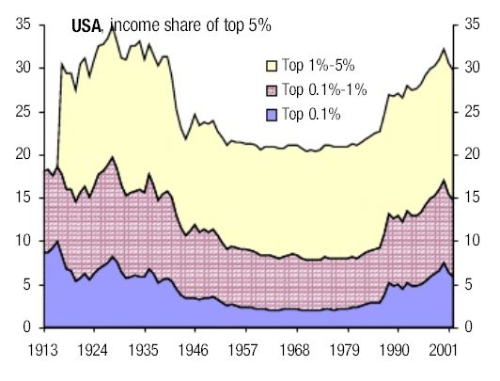
(Please see references 18 in the bibliography at the end of the report). Due difference in sources and method of calculations the income share estimates from tax based data do not exactly match Survey of Consumer Finance data. Source: Prof. Emmanuel Saez et. al., reference 18.
We will focus here on data from Prof. Emmanuel Saez of U.C. Berkeley who works with data from tax sources. Figure 2 shows the share of income for the top 0.1%, 1% and 5% in the U.S. since the 1910s. Clearly the fortunes of the top 0.1% fluctuate the most. Indeed, the fortunes of the top 5% (or even top 10%), or the top 1%, are almost entirely driven by the fortunes of the top 0.1% (roughly 100,000 households).
With the exception of the boom in the Roaring 1920s, this super-rich group kept losing out its share of incomes in WWI, the Great Depression and WWII, and till the early eighties. Why? The answers are unclear, but the massive loss of capital income (dividend, rents, interest income, but not capital gains) from progressive corporate and estate taxation is a possible candidate. The rise in their share since the mid-eighties might be related to the reduction in corporate and income taxes. Also, to a new wave of entrepreneurs and managers earning disproportionate incomes as they drove and participated in the ongoing technology boom. As Figure 3 shows, while in the early 20th century capital income was the big chunk for the top 0.1% of households, the resurgence in their fortunes since the mid-eighties was mainly from oversized salaries. The rich in the U.S. went from coupon-clipping, dividend-receiving rentiers to a Managerial Aristocracy indulged by their shareholders.

Figure 3. The Metamorphosis of the Highest 1% of Income Earners in the U.S.: from Rentier Rich to a Managerial Technocratic Aristocracy
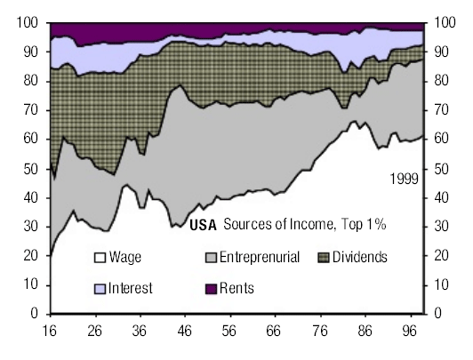
Please see reference 18 in the bibliography at the end of the report for the data underlying the chart. Based on tax returns data. Source: Citigroup Investment Research

EGALITARIAN JAPAN, CONTINENTAL EUROPE AND THE PLUTONOMIES OF CANADA AND THE UK
How did the Plutonomy fare in other countries over time? As Figures 4 and 5 show, the UK and Canada, pretty much follow the U.S. script. Japan, France, and the Netherlands are a bit different.
These were all plutonomies before the Great Depression, but the War, taxation, and new post-War institutional structures generated much more egalitarian societies, that hold even today. Only Switzerland remained unchanged. Neutrality through the wars saw its capital preserved, the lack of a progressive income and wealth tax regime, and low taxes helped.

Figure 4. Plutonomy At Work: The Income Share of the Top 1% Has Risen Dramatically Since the Late 1970s in the U.S., the U.K., and Canada
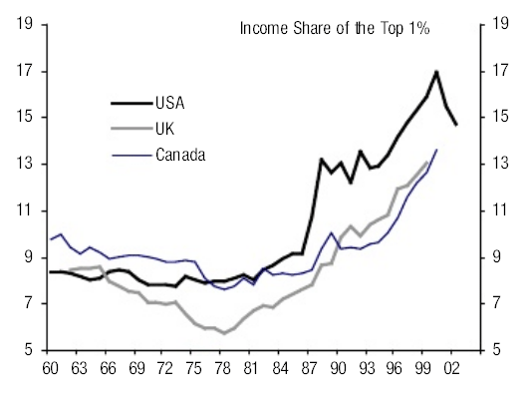
Please see references 18, 4, 22 in the bibliography at the end of the report for the data underlying the chart. Estimates based on tax return data. Source: Citigroup Investment Research

Figure 5. Of Egalitarian Bent: The Income Share of the Top 1% Is Much Smaller and Is Not Rising as Much, If at All, in Switzerland, the Netherlands, Japan, and France
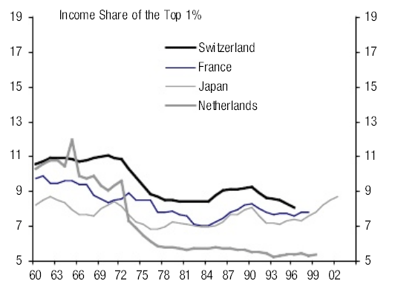
Please see references 7,17,15,4 in the bibliography at the end of the report for the data underlying the chart. Estimates based on tax return data. Source: Citigroup Investment Research
See Figures 6 thru 11 for a panorama of plutonomy and egalitarianism.

Figure 6. Plutonomy in the UK: The Income Share of the Top 0.5% Rose from Under 4% in the mid 70s to Over 9% in the Late 1990s
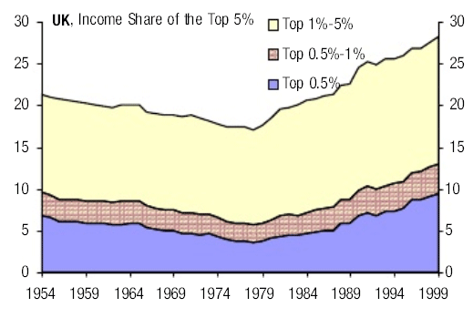
Please see reference 4 in the bibliography at the end of the report for the data. Source: Citigroup Investment Research

Figure 7. Return of Plutonomy in Canada: The Income Share of the Top 5% Is at the Highest Level Since the 1940s
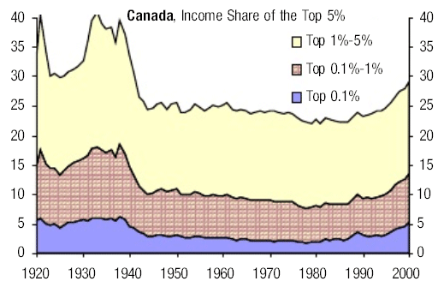
Please see reference 22 in the bibliography at the end of the report for the data. Source: Citigroup Investment Research and http://elsa.berkeley.edu/~saez/index.html
Please see reference 7 in the bibliography at the end of the report for the data. Source: Citigroup Investment Research

Figure 8. Switzerland Benefits From Neutrality: Remarkably Stable Income Share of the Very Rich Over the Past 60 Years

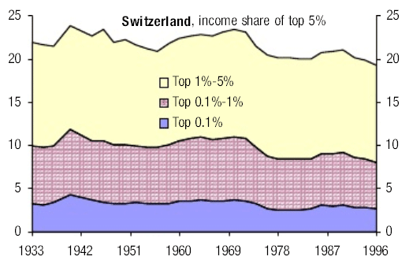

Figure 9. France: The Income Share of the Rich Fell During WWII But Stayed Stable in the 1980s and 1990s
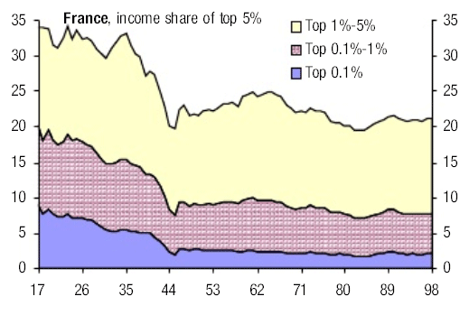
Please see reference 17 in the bibliography at the end of the report for the data. Source: Citigroup Investment Research

Figure 10. The Netherlands: Decline in the Share of the Top 5% and the Very Rich Until 1980. Share Relatively Stable in Recent Years
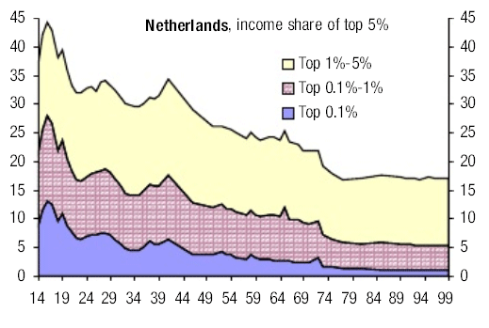
Please see reference 4 in the bibliography at the end of the report for the data. Source: Citigroup Investment Research

Figure 11. Japan: The Income Share of the Top 0.1% and the Top 1% Remarkably Flat in the Post-War Period.
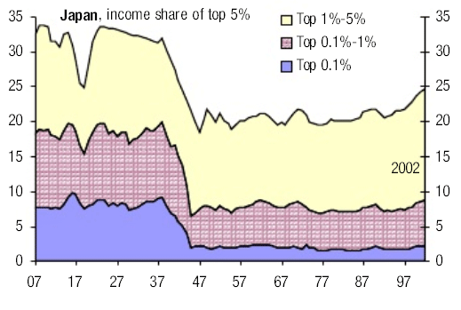
Please see reference 15 in the bibliography at the end of the report for the data. Source: Citigroup Investment Research

PLUTONOMY WAVES – TECHNOLOGY, IMMIGRATION, FINANCE, COMPLEXITY (AND DOPAMINE) DRIVEN?
The reasons why some societies generate plutonomies and others don’t are somewhat opaque, and we’ll let the sociologists and economists continue debating this one. Kevin Phillips in his masterly “Wealth and Democracy” argues that a few common factors seem to support “wealth waves” – a fascination with technology (an Anglo-Saxon thing according to him), the role of creative finance, a cooperative government, an international dimension of immigrants and overseas conquests invigorating wealth creation, the rule of law, and patenting inventions. Often these wealth waves involve great complexity.
“One explanation of …increasing polarization of wealth comes from considering these great transformations as surges of complexity – waves of economic, political and commercial change – profound enough to break down old vocational and price relationships, greatly favoring persons with position, capital, skills, and education” (page 259, author’s emphasis).
Clearly, a speculative instinct is key to generating and sustaining these complex and risky transformations. Here, a new, rather out-of-the box hypothesis suggests that dopamine differentials can explain differences in risk-taking between societies. John Mauldin, the author of “Bulls-Eye Investing” in an email last month cited this work. The thesis: Dopamine, a pleasure-inducing brain chemical, is linked with curiosity, adventure, entrepreneurship, and helps drive results in uncertain environments. Populations generally have about 2% of their members with high enough dopamine levels with the curiosity to emigrate. Ergo, immigrant nations like the U.S. and Canada, and increasingly the UK, have high dopamine-intensity populations. If encouraged to keep the rewards of their high dopamine-induced risk-seeking entrepreneurialism, these countries will be more prone to wealth waves, unequally distributed. Presto, a plutonomy driven by dopamine!
Interesting that Kevin Phillips also mentioned the role of immigrants in driving great wealth waves (oblivious to the role of dopamine, though). He emphasizes the role of the in-migration of skilled and well-capitalized refugees and cosmopolitan elites in catalyzing wealth waves. Being the son of refugee parents from the India-Pakistan partition in 1947, and now a wandering global nomad, I can see this argument quite clearly. (Also, I need to get my dopamine level checked.) Phillips talks of the four great powers – Spain in the fifty years after 1492, the United Provinces (Holland) in the sixteenth century, seventeenth century England, and nineteenth century U.S., all benefiting from waves of immigrants, fleeing persecution, and nabbing opportunities in distant lands.

WHY THE PLUTONOMY WILL GET STRONGER WHERE IT EXISTS, PERHAPS ATTRACT NEW COUNTRIES
We posit that the drivers of plutonomy in the U.S. (the UK and Canada) are likely to strengthen, entrenching and buttressing plutonomy where it exists. The six drivers of the current plutonomy: 1) an ongoing technology/biotechnology revolution, 2) capitalist- friendly governments and tax regimes, 3) globalization that re-arranges global supply chains with mobile well-capitalized elites and immigrants, 4) greater financial complexity and innovation, 5) the rule of law, and 6) patent protection are all well ensconced in the U.S., the UK, and Canada. They are also gaining strength in the emerging world.
Eastern Europe is embracing many of these attributes, as are China, India, and Russia. Even Continental Europe may succumb and be seduced by these drivers of plutonomy. As we argued in the Global Investigator,”Earnings – Don’t Worry, Capitalists Still on Top”, June 10, 2005, the profit share of GDP is highly likely to keep rising to the highs seen in the 1950s/60s. New markets like China and India, their contribution to the global labor supply, the ongoing productivity revolution, the quasi-Bretton Woodssystem in the U.S. dollar bloc, and inflation-fighting central banks should all help. However, a high profit share like in the 1950s/60s does not ensure plutonomy. Indeed, in the 1950s/60s, U.S. and other key countries did not see increasing income inequality.
Society and governments need to be amenable to disproportionately allow/encourage the few to retain that fatter profit share. The Managerial Aristocracy, like in the Gilded Age, the Roaring Twenties, and the thriving nineties, needs to commandeer a vast chunk of that rising profit share, either through capital income, or simply paying itself a lot. We think that despite the post-bubble angst against celebrity CEOs, the trend of cost-cutting balance sheet-improving CEOs might just give way to risk-seeking CEOs, re-leveraging, going for growth and expecting disproportionate compensation for it. It sounds quite unlikely, but that’s why we think it is quite possible. Meanwhile Private Equity and LBO funds are filling the risk-seeking and re-leveraging void, expecting and realizing disproportionate remuneration for their skills.

THOSE SCARY “GLOBAL IMBALANCES” – REFLECT PLUTONOMY AND DEMOGRAPHY, QUITE LOGICAL AND UNTHREATENING
We have all heard the lament. A bearish guru, somber and serious, spelling out that the end is near if something is not done urgently about those really huge, nasty “Global Imbalances”. The U.S. savings rate is too low, the U.S. current account deficit is too high, foreigners are not going to keep financing this unless compensated with higher interest rates, and a sharply lower U.S. dollar. The world, being so imbalanced, is about to tip over it’s axis, all hell is going to break loose, so don’t any equities – the risk premium is high reflecting these imbalances and is going to go higher (i.e., lower stock prices) when the earth finally does keel over.
A more balanced view acknowledges these nasty imbalances, but predicts a gentle, gradual dollar decline, a yuan revaluation, and the hope that Asians and European (ex- UK) consumers will embark on a spending journey, righting the world. A tough workout, but she’ll be right.
Almost all the smart folks we know – our investors, our colleagues, our friends in academia, politicians believe in some variant of these two stories. There are very few exceptions who consider these “Global Imbalances” not scary but perfectly natural and rather harmless. (We can think of Gavekal as one of these exceptions, but their repose of comfort is different from ours – they have a new book out “The Brave New World”, elucidating the new business model of global “Platform” companies, etc).
Our point here is not to dismiss the conventional views as outright wrong. However, we offer a competing view and, in some instance, a view that is complementary to the conventional explanation. Our view, if right, suggests that applying an excessive risk premium to “Global Imbalances” is a flawed approach to equity investing. Note that our house view, for instance, sees no cataclysmic collapse in the dollar. The U.S. current account deficit is anticipated to remain flat at 6.8% of GDP. The Japanese and the Euro surpluses are expected to continue. A plutonomy world is not inconsistent with these forecasts.

Figure 12. Global Imbalances: Plutonomies Are Running Current Account Deficits. Non-Plutonomies Are Running Current Account Surpluses
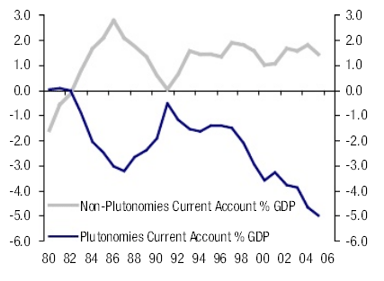
Note: For our purposes, Plutonomies = U.S., U.K. and Canada. Non-Plutonomies = EuroZone, Japan, and Switzerland. Missing are the newly industrialized nations of Asia and China.
Source: International Monetary Fund and Datastream
First a quick glance at these Global imbalances. Figure 12 shows the current account balances for plutonomies (the U.S., UK, and Canada) and the others – continental Europe and Japan. We have left out China and other emerging markets because we do not have their income inequality data, although they are definitely an important part of the “Global Imbalance” story.
Well, it seems that the plutonomies (the U.S., UK, and Canada together) have deteriorating current account balances; the others are running a combined current account surplus.
Current account balances are driven by three possible sources – the net savings of the government, the corporate sector and the household sector. Figure 13 shows our bottom- up estimates for corporate free cash flow/sales, a close cousin of corporate savings – these look similarly good across the world, both for plutonomies and the others. We won’t pursue this avenue as a key driver of today’s imbalances.

Figure 13. Free Cash Flow to Sales Is High Across the Major Regions. No Difference Between Plutonomies
and the Others
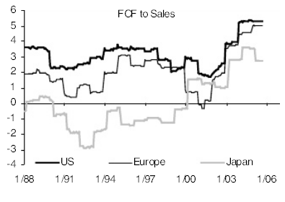
Source: Citigroup Investment Research and Worldscope
How about government deficits? Well, they seem to be equally bad in the U.S., UK, Continental Europe, and very bad in Japan. Hmm. We’ll leave this one alone too.

Figure 14. The Gap in the Savings Rate of Plutonomies and the Others Moves Closely with the Gap in the Current Account Balance
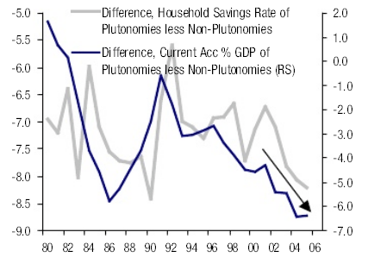
Note: For our purposes, Plutonomies = U.S., U.K. and Canada. Non-Plutonomies = EuroZone, Japan and Switzerland. Missing are the newly industrialized nations of Asia and China.
Source: International Monetary Fund and Datastream
We need to focus on the household sector (the consumer in simple English) as the key driver of those current account imbalances that so worry the equity bears. Indeed, Figure 14 shows the gap between the households sector’s savings rate for the plutonomies (U.S., UK, and Canada) less those of continental Europe and Japan. This gap is large and moves with the gap in the current accounts of these two blocs. Our contention is simple – while the drivers of savings rates in countries are many – we focus on plutonomy as a key new explanation for different savings rates in different countries. (As an aside, considerable empirical research shows that the external imbalances between the U.S., Europe, and Japan are driven by demography. The U.S. is just younger than Japan, driving household savings differences that drive those current account differences. This topic is beyond the scope of our story here. For those interested, check out “Capital Flows Among the G-7 Nations: A Demographic Perspective”, Michael Feroli, U.S. Federal Reserve Board, October 2003).
Our contention: when the top, say 1% of households in a country see their share of income rise sharply, i.e., a plutonomy emerges, this is often in times of frenetic technology/financial innovation driven wealth waves, accompanied by asset booms, equity and/or property. Feeling wealthier, the rich decide to consume a part of their capital gains right away. In other words, they save less from their income, the well- known wealth effect. The key point though is that this new lower savings rate is applied to their newer massive income. Remember they got a much bigger chunk of the economy, that’s how it became a plutonomy. The consequent decline in absolute savings for them (and the country) is huge when this happens. They just account for too large a part of the national economy; even a small fall in their savings rate overwhelms the decisions of all the rest. Figure 15 provides a simple example of how this happens.

Figure 15. A Numerical Example: If the Income Share of the Top Group Is High, A Reduction in the Savings Rate of the Top Income Group (due to Asset Appreciation, for example) Can More than Offset Any Increase in the Savings Rates of Others
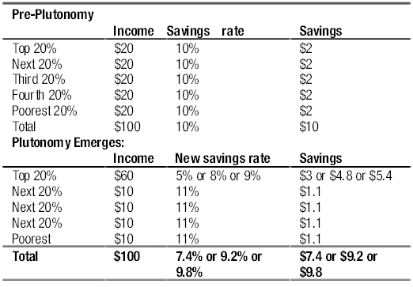
Source: Citigroup Investment Research
There is proof that high income earners, who saw their share of income go up in the U.S. in the nineties,and enjoyed the equity boom, reduced their savings rate as in our example. Indeed, in the real world, it went negative! Since that reduced savings rate was applied to their new enlarged chunk of income, sure enough the total savings rate fell sharply.
Dean Maki and Michael Palumbo, wrote the paper (at Alan Greenspan’s suggestion) that demonstrated this fall in the savings rate of the rich in response to the equity boom (See Maki and Palumbo,”Disentangling the Wealth Effect: A Cohort Analysis of Household Savings in the 1990s”, April 2001). Figure 16 demonstrates the savings rates at different points for different income groups.) The very rich, the top 20%, had a savings rate of 8%, much higher than other less affluent groups in 1992. By 2000 this savings rate had gone from 8%- to -2%! The wealth effect at work. And then this reduced savings rate of the rich hit their huge incomes, swollen by the plutonomy, savaging the U.S.’s overall savings rate. This is our contribution to the debate. Plutonomy plus an asset boom equals a drop in the overall savings rate. (Asset booms by themselves, i.e., the wealth effect by itself does not do the trick, as we will show soon.)

Figure 16. Household Savings Rates of the Rich Fell in the Stock Boom in the 1990s While Those of the Lower Income Groups Rose (Maki-Palumbo Estimates)
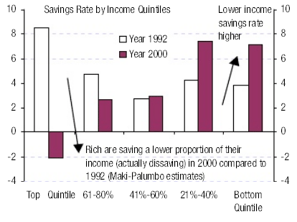
Please see reference 14 in the bibliography at the end of the report for the data underlying the chart. Based on tax returns data.
Source: Citigroup Investment Research
Let’s look at some of the coolest figures that amplify and verify this idea. Figure 17 plots the share of the top 1% of U.S. households since 1929. Our thesis is that the higher the share of income going to the top 1%, the lower the overall household savings rate (shown inverted in Figure 17). There is a pretty tight correlation between the two, despite the many other drivers of savings rates (demography, interest rates, financial deepening, retirement security, etc). The same information is shown in Figure 18, a scatter plot – when the rich take a very high share of overall income, the national household savings rate drops, and vice versa. In a plutonomy, the rich drop their savings rate, consume a larger fraction of their bloated, very large share of the economy. This behavior overshadows the decisions of everybody else. The behavior of the exceptionally rich drives the national numbers – the “appallingly low” overall savings rates, the “over-extended consumer”, and the “unsustainable” current accounts that accompany this phenomenon. We want to spend little time worrying about these (non)issues, neither do we think they warrant any risk premium on equities. They simply reflect the reality of demographic differences between nations, and that some nations are plutonomies, while others are not. Unequal inequality among nations is mirrored in the logical imbalances between them.

Figure 17. The Aggregate U.S. Household Savings Rate and the Income Share of the Top 1% Moves More Closely Together
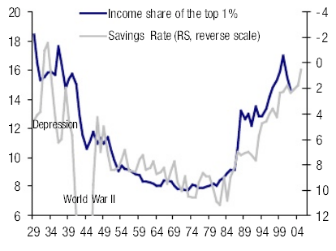
Please see reference 18 in the bibliography at the end of the report for the data underlying income share. Source: Bureau of Economic Analysis

Figure 18. There is a High and Negative Correlation Between the U.S. Household Savings Rate and Income Concentration (1929-02, World War II Years 1940-44 Excluded)
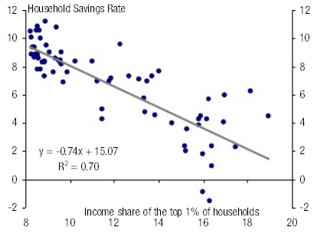
Note: Similar high correlations are obtained even if we use the income share of the top 10% (RSq = 0.70) or the income share of the top 5% (RSq = 0.73).
Please see reference 18 in the bibliography at the end of the report for the data underlying income share.
Source: Citigroup Investment Research
How about more empirical verification of the relationship between the household savings rate and the share of the rich in other plutonomies like the UK and Canada? Figure 19 shows the relationship for the UK using data from 1951 onwards. Note the clear negative relationship that we expect. In the nineties, there seems to have been an upward shift in the relationship between the UK personal savings rate and income inequality. There are number of drivers for the savings rate, as highlighted earlier, and the impact of these other drivers could shift the relationship around – our comfort comes from the persistence of the negative relationship in the UK.

Figure 19. In the U.K., A Strongly Negative Relationship Between Income Concentration (Plutonomy) and the Aggregate Household Savings Rate. The Relationship Shifted Upward in the 1990s
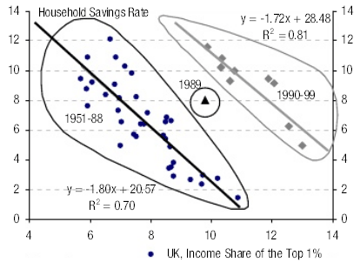
Please see reference 4 in the bibliography at the end of the report for the data underlying the chart. Based on tax returns data. Source: Citigroup Investment Research

Figure 20. Canada Also Shows a Close Relationship Between Income Concentration (Plutonomy) and the Aggregate Household Savings Rate
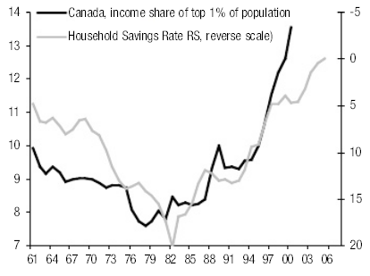
Please see reference 22 in the bibliography at the end of the report for the data underlying the chart. Based on tax returns data. Source: Citigroup Investment Research and http://elsa.berkeley.edu/~saez/index.html

Figure 21. Canada: High and Negative Correlation Between Aggregate Household Savings Rates and IncomeConcentration
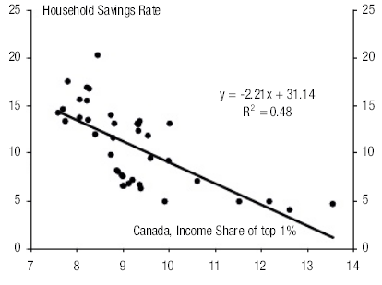
Note: Similar high correlations are obtained even if we use the income share of the top 10% (RSq = 0.60) or the income share of the top 5% (RSq = 0.62).
Source: Citigroup Investment Research and http://elsa.berkeley.edu/~saez/index.html
Canada also confirms our thesis. A plutonomy begets a lower household savings rate. See Figures 20 and 21. We have also attempted, in Figure 22, to put the relationship on a cross border-basis for the eight countries where we have comparable data. Again, plutonomies like the U.S., Canada, and the UK have lower household savings rates than the more egalitarian countries like France, the Netherlands, Switzerland, Spain, and Japan.

Figure 22. Cross-Border Comparison: Countries With Lower Income Concentration (Continental Europe) Tend to Have Higher Aggregate Household Savings Rates High Income Concentration (Plutonomy) Is Associated with Lower Household Savings Rates
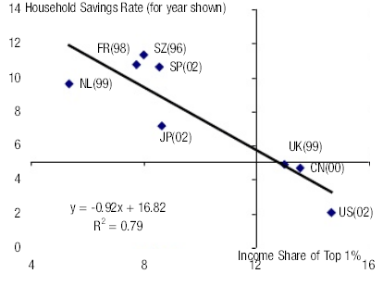
Please see references 18, 4, 22, 7, 17, 15 in the bibliography at the end of the report for the data underlying the chart. Based on tax returns data. Source: Citigroup Investment Research and http://elsa.berkeley.edu/~saez/index.html
One quick point – we asserted earlier that a plutonomy plus an asset boom corresponded with a decline in the household savings rate. It was not just the standard asset boom spawning a wealth effect and ergo higher consumer spending and a lower savings rate. Is there as tight a relationship between asset prices and the savings rate as there is between income inequality and the savings rate (correlation -0.7) shown in Figure 17? Well, in Figure 23 we plot the 10-year returns of the U.S. stock market with the household savings rate. While the relationship is tight in the great bull market between 1982-2000, the huge bull market in the 1950s and 1960s sees no real wealth effect. (The overall correlation of +0.19, i.e., low AND the wrong sign). Why? Among other sensible reasons we do not know, we think it was the absence of plutonomy in that period that kept the spending decisions of the rich, obviously enjoying solid equity gains, from dominating the overall numbers. They were just not disproportionately a big part of the economy then. That would have to wait for the 1980s.

Figure 23. U.S.: It Takes Plutonomy (Income Concentration)a nd Asset Inflation to Lower the Aggregate Household Savings Rate – Asset Inflation Alone May Not Be Enough
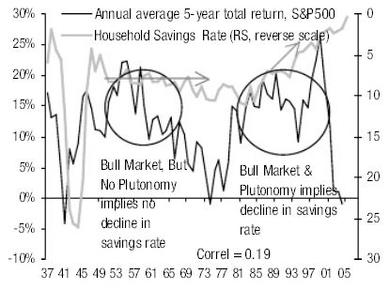
Source: Citigroup Investment Research and Datastream
A skeptic, while agreeing with our plutonomy thesis, may still not be convinced about the ability of households to sustain the low savings rate. Surely, even in the brave new world of plutonomies we describe, households cannot forever keep their savings rate low? We have two interesting dynamics in place that should prevent a sharp drop in consumption and so pushing the savings rate higher. One, the difference of the household’s financial assets to disposable income (assets with value of housing stock excluded) and its liabilities to disposable income exceeds its historical average. Households can afford to run down their assets to finance consumption for a while. Please see Figure 24 we have borrowed from Lewis Alexander, our Chief Economist.

Figure 24. The U.S. Household’s Financial Assets Are Far in Excess of Its Liabilities Even After the Correction in the TMT Bubble. It Can Afford to Maintain Its Low Savings Rate for a While
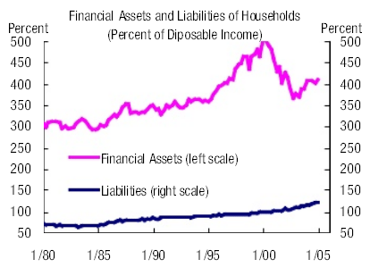
Source: Bureau of Economic Analysis, Federal Reserve Board, and Citigroup Investment Research
Two, as this note has been arguing it is the rich who are driving the low savings rate and high consumption in plutonomies. For the top decile in the U.S., the total net worth to income ratio is exceptionally high at 7.5 times compared to 4.5 times for the rest of the households. The high cushion of net worth of the rich, combined with their gigantic share of income and consumption can sustain the low savings rate (and therefore the current account deficit) in the plutonomies. Please see figure 25.

Figure 25. U.S.: Net Worth to Income Ratio for the Rich Is High and Rising. Drives and Sustains High Consumption out of Their Massive Income; Keeping Aggregate Savings Rate Low and Current Account Deficit Large
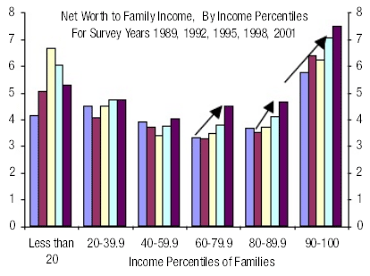
Source: Survey of Consumer Finances, Federal Reserve Board, and Citigroup Investment Research
To summarize so far, plutonomies see the rich absorb a disproportionate chunk of the economy, their decision to lower their savings rate, often corresponding to the asset booms that often accompany plutonomy, has a massive negative impact on reported aggregate numbers like savings rates, current account deficits, consumption levels, etc. We believe the key global imbalance is that some large economies have become plutonomies, and others have not — this imbalance in inequality expresses itself in the standard scary “global imbalances” that so worry the bears and most observers. They do not worry us much. In addition, the emerging market entrepreneur/plutocrats (Russian oligarchs, Chinese real estate/manufacturing tycoons, Indian software moguls, Latin American oil/agriculture barons), benefiting disproportionately from globalization are logically diversifying into the asset markets of the developed plutonomies. They are attracted by the facets that facilitated the re-emergence of plutonomies in the U.S., UK, and Canada – technology, internationalism, the rule of law, financial innovation and capitalist-friendly cooperative governments. This further inflates the asset markets in these plutonomies, enabling the rich there to lower their savings rates further, and worsening their current account balances further. Just as misery loves company, we posit that the “plutos” like to hang out together.
We stress that our analysis of the relationship between income concentration (plutonomy) and the household savings rates is confined to industrialized countries. This relationship in emerging markets is weak or non-existent. As mentioned earlier, the emerging markets’ elites often do their spending and investment in developed plutonomies rather than at home.

WHAT MIGHT CHANGE THIS?
Our view that plutonomy is driving savings and consumption imbalances is all very well. But before examining how to make money from this theme, we want to look at what might cause it to change.

THE DEATH OF PLUTONOMY
At the heart of plutonomy, is income inequality. Societies that are willing to tolerate/endorse income inequality, are willing to tolerate/endorse plutonomy.
Earlier, we postulated a number of key tenets for the creation of plutonomy. As a reminder, these were: 1) an ongoing technology/biotechnology revolution, 2) capitalist- friendly governments and tax regimes, 3) globalization that re-arranges global supply chains with mobile well-capitalized elites and immigrants, 4) greater financial complexity and innovation, 5) the rule of law, and 6) patent protection.
We make the assumption that the technology revolution, and financial innovation, are likely to continue. So an examination of what might disrupt Plutonomy – or worse, reverse it – falls to societal analysis: will electorates continue to endorse it, or will they end it, and why.
Organized societies have two ways of expropriating wealth – through the revocation of property rights or through the tax system.
Capital markets, like human beings, generally strive for certainty and stability. The pricing of assets is easier, projections more comfortable, etc. For this reason, in developed capital markets, governments have learnt the lessons of level playing fields, regulatory certainty, and the sanctity of property rights.
However this does not mean that governments are incapable of revoking property rights. While this tends to be something more often seen in countries with a shorter history of capitalist democracy, such as the Ukraine (attempts to undo prior privatizations), or Russia (where some of our clients believe events surrounding Mikhail Khodorovsky to be a form of nationalization), it can happen in the strangest of places. For example, in 2001, UK government withdrawal of financial support bankrupted Railtrack, the UK rail operator, effectively re-nationalizing railway assets on the cheap.
But these moves are exceptional and generally counter-productive as they raise the risk premium, in theory, for future transactions with that power. If the government is willing to be a contestant and simultaneously set and change the rules of the game to their advantage, the rewards of the game must rise to attract other participants.
The more likely means of expropriation is through the tax system. Corporate tax rates could rise, choking off returns to the private sector, and personal taxation rates could rise – dividend, capital-gains, and inheritance tax rises would hurt the plutonomy.
There is a third way to change things though not necessarily by expropriation, and that is to slow down the rate of wealth creation or accumulation by the rich – generally through a reduction in the profit share of GDP. This could occur through a change in rules that affect the balance of power between labor and capital. Classic examples of this tend to fall under one of two buckets – the regulation of the domestic labor markets through minimum wages, regulating the number of hours worked, deciding who can and cannot work etc, or by dictating where goods and services can be imported from (protectionism).

WHERE DO WE STAND TODAY?
In the plutonomies, there seems little threat from the first of these challenges: blatant expropriation of property by governments. There are few examples of governments changing the rules in the plutonomies and engaging in widespread nationalization, or asset re-distribution.
Likewise, if anything, the trends of taxation are positive for corporates, with fiscal competition in Europe forcing rates lower, year by year. Ironically, this is happening most in non-plutonomy countries, like Germany. This is good for the profit share, of which the mega-rich, through their holdings of equity, are “long”.
However, even if the profit share is rising, the fruits of those profits could be taxed before ending up in the pockets of the rich. In other words, dividend, capital gains and estate taxes could all rise. However, we struggle to find examples of this happening. Indeed, in the U.S., the current administration’s attempts to change the estate tax code and make permanent dividend tax cuts, plays directly into the hands of the plutonomy. While such Pluto-friendly policies are not widely being copied around the world, we have not found examples of the opposite occurring elsewhere.
Protectionism or regulation. Here, we believe lies a cornerstone of the current wave of plutonomy, and with it, the potential for capitalists around the world to profit. The wave of globalization that the world is currently surfing, is clearly to the benefit of global capitalists, as we have highlighted. But it is also to the disadvantage of developed market labor, especially at the lower end of the food-chain.
There are periodic attempts by countries to redress this balance – Jospin’s introduction of the 35 hour working week in France to the anticipated benefit of labor being one example. But in general, on-going globalization is making it easier for companies to either outsource manufacturing (source from cheap emerging markets like China and India) or “offshore” manufacturing (move production to lower cost countries).
Brunswick, the recreational services company, is typical of the “globalized” world we now live in. We were intrigued to see in the company’s September 27 presentation, that in 2000, the company had 17 manufacturing/procurement centers globally, 14 of them in North America, high cost European countries or Japan. Today, five years later, they have 40 manufacturing/sourcing /engineering centers. Of these half are in low-cost countries. Such examples abound in today’s globalized world.
The final option for countries willing to consider it, is to in-source labor. For example, in the UK, between May 2004 accession of the 10 new countries into the EU, and March 2005, 176,000 workers have moved from the accession countries to the UK and joined the workforce. Leaving aside any demand benefits they might bring, this does, in theory keep the price of labor contained. It interests us that the Plutonomy countries (U.S.A, UK, Australia, and Canada) all have – generally – a welcoming attitude to skilled immigration. Of the pre-accession EU 15 countries, only a handful, the UK and Ireland included allow full and free labor movement from the new EU 10 countries into their labor markets. The vast majority, Germany, Austria, Italy etc., are refusing to allow accession countries full freedom of movement until 2009-11.
So, property rights look as if they are being protected, tax policies helpful, and the profit share should continue to rise, through globalization and the productivity/technology wave.
Our conclusion? The three levers governments and societies could pull on to end plutonomy are benign. Property rights are generally still intact, taxation policies neutral to favorable, and globalization is keeping the supply of labor in surplus, acting as a brake on wage inflation.

IS THERE A BACKLASH BUILDING?
Plutonomy, we suspect is elastic. Concentration of wealth and spending in the hands of a few, probably has its limits. What might cause the elastic to snap back? We can see a number of potential challenges to plutonomy.
The first, and probably most potent, is through a labor backlash. Outsourcing, offshoring or insourcing of cheap labor is done to undercut current labor costs. Those being undercut are losers in the short term. While there is evidence that this is positive for the average worker (for example Ottaviano and Peri) it is also clear that high-cost substitutable labor loses.
Low-end developed market labor might not have much economic power, but it does have equal voting power with the rich. We see plenty of examples of the outsourcing or offshoring of labor being attacked as “unpatriotic” or plain unfair. This tends to lead to calls for protectionism to save the low-skilled domestic jobs being lost. This is a cause championed, generally, by left-wing politicians. At the other extreme, insourcing, or allowing mass immigration, which might price domestic workers out of jobs, leads to calls for anti-immigration policies, at worst championed by those on the far right. To this end, the rise of the far right in a number of European countries, or calls (from the right) to slow down the accession of Turkey into the EU, and calls from the left to rebuild trade barriers and protect workers (the far left of Mr. Lafontaine, garnered 8.5% of the vote in the German election, fighting predominantly on this issue), are concerning signals. This is not something restricted to Europe. Sufficient numbers of politicians in other countries have championed slowing immigration or free trade (Ross Perot, Pauline Hanson etc.).
A second related threat, might come from productive labor no longer maintaining its productive edge. Again, we find Kevin Phillips’s arguments in his book, Wealth and Democracy, fascinating. Phillips highlights the problems in the late 1700s Netherlands, where an increasing obsession with financial speculation (sound familiar?) caused non- financial skilled labor that had built that country’s wealth, to seek their success in other countries. Likewise, Britain’s failure to keep its educational advantage in what were then high-tech areas caused them to lose their competitive advantage that had been maintained until the First World War. Are there similarities with Asian economies, versus the plutonomies, today?
A third threat comes from the potential social backlash. To use Rawls-ian analysis, the invisible hand stops working. Perhaps one reason that societies allow plutonomy, is because enough of the electorate believe they have a chance of becoming a Pluto- participant. Why kill it off, if you can join it? In a sense this is the embodiment of the “American dream”. But if voters feel they cannot participate, they are more likely to divide up the wealth pie, rather than aspire to being truly rich.
Could the plutonomies die because the dream is dead, because enough of society does not believe they can participate? The answer is of course yes. But we suspect this is a threat more clearly felt during recessions, and periods of falling wealth, than when average citizens feel that they are better off. There are signs around the world that society is unhappy with plutonomy – judging by how tight electoral races are. But as yet, there seems little political fight being born out on this battleground.
A related threat comes from the backlash to “Robber-barron” economies. The population at large might still endorse the concept of plutonomy but feel they have lost out to unfair rules. In a sense, this backlash has been epitomized by the media coverage and actual prosecution of high-profile ex-CEOs who presided over financial misappropriation. This “backlash” seems to be something that comes with bull markets and their subsequent collapse. To this end, the cleaning up of business practice, by high- profile champions of fair play, might actually prolong plutonomy.
Our overall conclusion is that a backlash against plutonomy is probable at some point. However, that point is not now. So long as economies continue to grow, and enough of the electorates feel that they are benefiting and getting rich in absolute terms, even if they are less well off in relative terms, there is little threat to Plutonomy in the U.S., UK, etc.
But the balance of power between right (generally pro-plutonomy) and left (generally pro-equality) is on a knife-edge in many countries. Just witness how close the U.S. election was last year, or how close the results of the German election were. A collapse in wealth in the plutonomies, felt by the masses, and/or prolonged recession could easily raise the prospects of anti-plutonomy policy.
We should at this point make clear that we have no view on whether plutonomies are good or bad, our analysis here is based on the facts, not what we want society to look like.

HOW TO PLAY PLUTONOMY
So, Plutonomies exist, and explain much of the world’s imbalances. There is no such thing as “The U.S. Consumer” or “UK Consumer”, but rich and poor consumers in these countries, with different savings habits and different prospects. The rich are getting richer; they dominate spending. Their trend of getting richer looks unlikely to end anytime soon.
How do we make money from this theme? We see two ways. The first is simple. If you believe, like us, that the Plutonomy exists, and explains why global imbalances have built up (for example the savings rate differentials), and you believe there is no imminent threat to plutonomy, you must in turn believe that the current “end of the world is nigh” risk premium on equities, due to current account deficits, is too high. Conclusion: buy equities. There is however a more refined way to play plutonomy, and this is to buy shares in the companies that make the toys that the Plutonomists enjoy.
As the rich have been getting progressively richer over the last 30 years, saving less and spending more, the fortunes of companies that sell to the rich ought to have been good. Not only have the rich been earning and spending more, but they are less price elastic than typical consumers. In fact we believe they have a preference for Giffen goods, i.e., the more expensive they are, the more they are purchased.
One way we can measure this is to look at price inflation for a basket of luxury goods. Thankfully, Forbes magazine each year publishes its “Cost of Living Extremely Well” Indices, which measures annual price changes in a basket of high end consumer items, from luxury yachts, to the cost of dinner at the world’s top restaurants, right down to the cost of a pair of fine English shoes.
Figure 26 shows this index, back to 1976, and the aggregate CPI for the U.S. Since 1976, when this index started, the inflation rate of luxury products that the rich buy, has risen far faster than overall CPI. Turned around another way, the corporate price deflator for luxury items, or pricing power for luxury companies, has been relatively positive.

Figure 26. Forbes “The Cost of Living Extremely Well Index” – Pricing Power for Luxury Goods Much Stronger than Overall CPI Over Time
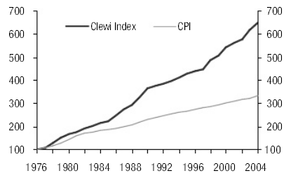
Source: Citigroup Investment Research, Forbes, and Datastream
This pricing power is surely a huge benefit to luxury related companies. In theory, all other things being equal, this added pricing power should have led to outperformance, and if maintained, should continue to do so.

Figure 27. The Plutonomy Basket: Stocks That Leverage of Plutonomy
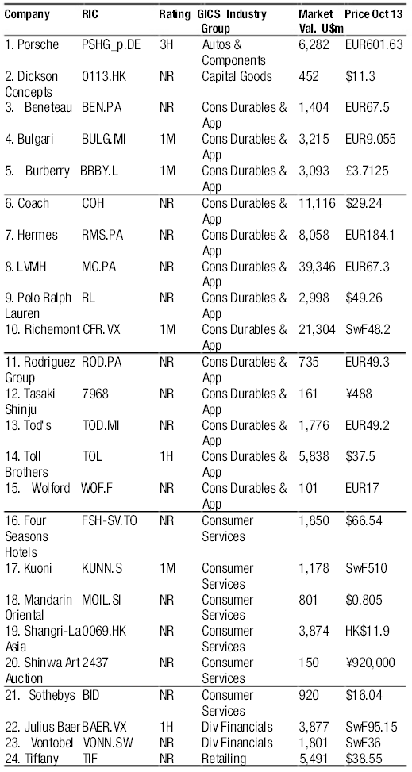
Source: Citigroup Investment Research and Datastream
To test this, we built a basket of companies that serve or sell to the rich, the beneficiaries of Plutonomy. The companies – not all followed by Citigroup Investment Research – fall into a number of areas, from Private Banking (for example Julius Baer), to traditional luxury goods like Bulgari, through art auction houses (e.g., Sotheby’s), and of course luxury toys, such as Porsche. The full basket is in Figure 27. We emphasize that a stock’s inclusion in this basket in no way makes it a recommended buy, from Citigroup Investment Research, unless rated so by our respective analyst. The basis for inclusion was that a majority of the company’s revenues were/are derived from the “rich”. Hence Bombardier, the manufacturer of Lear Jets, did not make the list, though clearly that product is a typical plutonomy “toy”. This list is by no means exhaustive.
So how did it perform? Since 1985, our starting point for this plutonomy basket, it has generated an annualized return of 17.8%, handsomely outperforming indices such as the S&P500.
“Aha”, we hear you say, “you are picking up a sector effect!”Well, we tried sector-adjusting our basket, to remove what is a predominantly consumer sector bias, and found this made very little difference to the results. The basket still performed very well through the 1980s and 1990s. While there is some survivor bias, in our list, compared to standard indices, we nevertheless find what we expected: that the plutonomy basket performed exceptionally well.
So well in fact, that our fashion-loving colleague Priscilla pointed out the obvious – “wow, I can get rich by owning the plutonomy stocks, and then spend my money on these products”. Figure 28 shows the performance of the Plutonomy Basket back to 1985, in absolute terms, and in Figure 29 relative to the MSCI AC World Index.
This is a handsome outperformance. But there are periods where the basket performed poorly or less well, for example after the 1987 stock market crash, or in a more muted fashion during the recent bear market.

Figure 28. The Plutonomy Basket Has Handsomely Outperformed the Global Equity Market Since 1985, on Average by 6.8% a Year
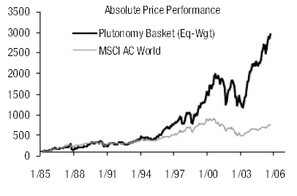
Note: Price performance of the Plutonomy basket is calculated based on 5 stocks in 1985, 14 stocks in 1990, 20 stocks in 2000 and 24 stocks in
2005.
Source: Citigroup Investment Research, Datastream, and MSCI

Figure 29. Up, Up and Away: Plutonomy Basket Outperforms World Equities Handsomely
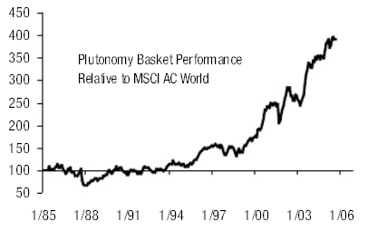
Source: Citigroup Investment Research, Datastream, and MSCI
This is hardly a major surprise; given that the Plutonomy is fuelled by an equity market boom, and threatened by a bust, given the rich are disproportionately long the equity market.
The average person, by contrast, tends to have a disproportionate amount of their wealth tied up in housing. While a stock market boom should help the rich, a housing boom should help the average Joe.
Belsky and Prakken’s paper suggests that housing booms tend to get reflected in spending more rapidly than stock market booms – in other words, the wealth effect from house price rises gets turned on more quickly than from equity prices rising.
It is interesting when we look at the performance of the stock market relative to the housing market, and compare this to the performance of the Plutonomy basket relative to the broad equity market, we find that during periods of house price appreciation relative to stock market appreciation, our plutonomy basket moves sideways. See Figure 30.

Figure 30. If Stocks beat Housing, Plutonomy Basket Does Even Better – The Rich Have disproportionately More Equities than Housing
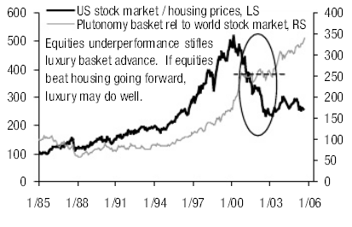
Note: U.S. housing prices based on NAR Median Sales Prices of existing 1-Family Homes
Source: Citigroup Investment Research, Datastream, National Association of Realtors, and MSCI
If like us, you believe that attempts by the UK, U.S., and Australian authorities to cool the housing market is likely to work, and you believe, like us, that equities are likely to perform well in coming years, this is a good time to switch out of stocks that sell to the masses and back to the plutonomy basket.

Conclusion
We are not often shocked. But shocked we were, when we published our note on the Irrelevance of Oil, several weeks ago, and discovered just how significant the rich were in terms of income, wealth and consumption in the U.S.
Looking into this in more detail, we have found that the U.S. is not alone. Un-equal societies abound in the Anglo-Saxon world. This income inequality, we have called Plutonomy.
Outlandish it may sound, but examined through the prism of plutonomy, some of the great mysteries of the economic world seem to look less mystifying. As we showed, there is a clear relationship between income inequality and low savings rates: the rich are happy to run low or negative savings given their growing pool of wealth. In turn, those countries with low/negative household savings rates tend to be the countries associated with current account deficits.
So why should we equity strategists care about this? Well simply, because the issue that most consistently seems to vex our equity client base, from a top down perspective, is the U.S. current account deficit, the associated lack of savings, and the build-up of debt. It is both intellectually fashionable and elegant, apparently, to attack “the crazy American consumer, and his/her overspending”.
This has of course, from a portfolio perspective, been a costly trade to run-with, over the last 10 years. Those “crazy American consumers” seem to be in rude health. Their imminent demise has been a long time imminent.
If we are right, that the rise of income inequality, the rise of the rich, the rise of plutonomy, is largely to blame for these “perplexing” global imbalances. Surely, then, it is the collapse of plutonomy, rather than the collapse of the U.S. dollar that we should worry about to bring an end to imbalances. In other words, we are fretting unnecessarily about global imbalances. In turn, the risk premium on equities is probably too high.
Secondly, we hear so often about “the consumer”. But when we examine the data, there is no such thing as “the consumer” in the U.S. or UK, or other plutonomy countries. There are rich consumers, and there are the rest. The rich are getting richer, we have contended, and they dominate consumption.
As the rich have been getting richer, so too stocks associated with the rich, have performed exceptionally well. Our Plutonomy Basket, generated returns of 17.8% per annum, on average, from 1985. If Plutonomy continues, which we think it will, if income inequality is allowed to persist and widen, the plutonomy basket should continue to do very well. Names in this basket that our analysts recommend as buys include Julius Baer, Bulgari, Burberry, Richemont, Kuoni, and Toll Brothers.

Bibliography
1. Alveredo, Facundo & Saez, Emmanuel. “Income and Wealth Concentration in Spain
in a Historical and Fiscal Perspective.September 2005.
2. Atkinson, A.B. “Income Inequality in OECD Countries: Data and Explanations:
Center for Economic Studies Working Paper No. 881.”Center for Economic
Research, Feb. 2003
3. Atkinson, A.B. “Top Incomes in the United Kingdom over the Twentieth Century”. Discussion Paper in Economic and Social History, Univeristy of Oxford. December 2003.
4. Atkinson, A.B. and Salverda, Wiemer “Top Incomes in the Netherlands and the
United Kingdom over the Twentieth Century”.Discussion Paper in Economic and
Social History, Univeristy of Oxford. June 2003.
5. Bayoumi, Tamim & Edison, Hali “Is Wealth Increasingly Driving Consumption?”.
DNB Staff Reports 2003, No. 101
6. © Belsky, Eric & Prakken, Joel.”Housing Wealth Effects: Housing’s Impact on
Wealth Accumulation, Wealth Distribution and Consumer Spending”. December
2004. W-4-13. Joint Center for Housing Studies. © 2004 President and Fellows of
Harvard College.
7. Dell, Fabian; Piketty, Thomas; Saez, Emmanuel;”Income and Wealth Concentration
in the Switzerland Over the 20thCent ury”.Discussion Paper 590. Centre for
Economic Policy Research. May 2005.
8. Feroli, Michael.”Capital Flows Among the G-7 Nations: A Demographic
Perspective”. Federal Research Board Division of Research and Statistics. October
2003.
9. Heshmati, Almas “The World Distribution of Income and Income Inequality”, IZA
Discussion Paper No. 1267. Institute for the Study of Labor. August 2004.
10. Juster F. Thomas; Lupton, Joseph P.; Smith, James P.; Stafford, Frank.”The Decline
in Household Saving and the Wealth Effect”. University of Michigan, Board of
Governors of the Federal Reserve System. April 2004.
11. Kaplan, Richard “Economic Inequality and the Role of Law”. Kaplan PP5.
December 2003.
12. Kpczuk, Wojciech & Saez, Emmanuel.”Top Wealth Shares in the United States,
1916-2000: Evidence From Estate Tax Returns”. National Bureau of Economic
Research. March 2004.
13. Leigh, Andrew “Permanent Income Inequality: Australia, Britain, Germany, and
United States Compared”. Social Policy Evaluation, Analysis and Research Centre,
Research School of Social Sciences, Australian National University. September
2005.
14. Maki, Dean M. & Palumbo, Michael G.”Disentangling the Wealth Effect: A
Cohort Analysis of Household Saving in the 1990′s”.Board of Governors of the
Federal Reserve System & Putnam Investments. April 2001
15. Moriguchi, Chiaki & Saez, Emmanuel.”The Evolution of Income Concentration in
Japan, 1885 – 2002: Evidence from Income Tax Statistics”.National Bureau of
Economic Research. August 2005.
16. Phillips, Kevin.”Wealth and Democracy”. Broadway Books. 2002.
17. Piketty, Thomas “Income Inequality in France 1901 – 1998″ April 2001.
18. Piketty, Thomas & Saez, Emmanuel “Income Inequality in the United States, 1913
- 2002.November 2004.
19. Schmidt-Hebbel, Kalus & Serven, Luis.”Income Inequality and Aggregate
Saving. The Cross-Country Evidence”.Policy Research Working Paper 1561. The
World Bank, Policy Research Department, Macroeconomics and Growth Division,
January 1996.
20. Saez, Emmanual “Income and Wealth Concentration in a Historical and
International Perspective”.February 2004.
21. Saez, Emmanuel “Reported Incomes and Marginal Tax Rates, 1960-2000:
Evidence and Policy Implications”.National Bureau of Economic Research.
January 2004.
22. Saez, Emmanuel.”Top Incomes in the United States and Canada over the
Twentieth Century”
23. Saez, Emmanuel & Veall, Michael R.”The Evolution of High Incomes in
Northern America: Lessons from Canadian Evidence”.The American Economic
Review. June 2005.
24. Smeeding, Timothy.”Globalization, Inequality, and the Rich Countries of the G-
20: Evidence From the Luxembourg Income Study”. The Maxwell School of
Syracuse University Center for Policy Research. November 2002.
25. Smeeding, Timothy M.”Public Policy, Economic Inequality, and Poverty: The
United States in Comparative Perspective”.The Maxwell School of Syracuse
University Center for Policy Research. May 2005.
26. Wolff, Edward N.”Changes in Household Wealth in the 1980′s and 1990′s in the
U.S.” International Perspectives on Household Wealth, Elgar Publishing Ltd., April
2004.

ANALYST CERTIFICATION
APPENDIX A-1
I, Ajay Kapur, Niall Macleod, Narendra Singh, research analyst and the author of this report, hereby certify that all of the views expressed in this research report accurately reflect my personal views about any and all of the subject issuer(s) or securities. I also certify that no part of my compensation was, is, or will be directly or indirectly related to the specific recommendation(s) or view(s) in this report.
IMPORTANT DISCLOSURES
Analysts’ compensation is determined based upon activities and services intended to benefit the investor clients of Citigroup Global Markets Inc. and its affiliates (“the Firm”). Like all Firm employees, analysts receive compensation that is impacted by overall firm profitability, which includes revenues from, among other business units, the Private Client Division, Institutional Equities, and Investment Banking.
Citigroup Investment Research Ratings Distribution
Data current as of 30 September 2005
Buy
Hold
Sell
Citigroup Investment Research Global Fundamental Coverage (2650)
41%
42%
18%
% of companies in each rating category that are investment banking clients
48%
47%
32%
Guide to Fundamental Research Investment Ratings:
Citigroup Investment Research’s stock recommendations include a risk rating and an investment rating.
Risk ratings, which take into account both price volatility and fundamental criteria, are: Low (L), Medium (M), High (H), and Speculative
(S).
Investment ratings are a function of Citigroup Investment Research’s expectation of total return (forecast price appreciation and dividend yield within the next 12 months) and risk rating.
For securities in developed markets (US, UK, Europe, Japan, and Australia/New Zealand), investment ratings are: Buy (1) (expected total return of 10% or more for Low-Risk stocks, 15% or more for Medium-Risk stocks, 20% or more for High-Risk stocks, and 35% or more for Speculative stocks); Hold (2) (0%-10% for Low-Risk stocks, 0% 15% for Medium-Risk stocks, 0%-20% for High-Risk stocks, and
0%-35% for Speculative stocks); and Sell (3) (negative total return).
For securities in emerging markets (Asia Pacific, Emerging Europe/Middle East/Africa, and Latin America), investment ratings are: Buy
(1) (expected total return of 15% or more for Low-Risk stocks, 20% or more for Medium-Risk stocks, 30% or more for High-Risk stocks,
and 40% or more for Speculative stocks); Hold (2) (5%-15% for Low-Risk stocks, 10%-20% for Medium-Risk stocks, 15%-30% for
High-Risk stocks, and 20%-40% for Speculative stocks); and Sell (3) (5% or less for Low-Risk stocks, 10% or less for Medium-Risk
stocks, 15% or less for High-Risk stocks, and 20% or less for Speculative stocks).
Investment ratings are determined by the ranges described above at the time of initiation of coverage, a change in risk rating, or a
change in target price (subject to limited management discretion). At other times, the expected total returns may fall outside of these
ranges because of market price movements and/or other short-term volatility or trading patterns. Such interim deviations from specified
ranges will be permitted but will become subject to review by Research Management. Your decision to buy or sell a security should be
based upon your personal investment objectives and should be made only after evaluating the stock’s expected performance and risk.
Between September 9, 2002, and September 12, 2003, Citigroup Investment Research’s stock ratings were based upon expected
performance over the following 12 to 18 months relative to the analyst’s industry coverage universe at such time. An Outperform (1)
rating indicated that we expected the stock to outperform the analyst’s industry coverage universe over the coming 12-18 months. An
In-line (2) rating indicated that we expected the stock to perform approximately in line with the analyst’s coverage universe. An
Underperform (3) rating indicated that we expected the stock to underperform the analyst’s coverage universe. In emerging markets, the
same ratings classifications were used, but the stocks were rated based upon expected performance relative to the primary market index
in the region or country. Our complementary Risk rating system — Low (L), Medium (M), High (H), and Speculative (S) — took into
account predictability of financial results and stock price volatility. Risk ratings for Asia Pacific were determined by a quantitative screen
which classified stocks into the same four risk categories. In the major markets, our Industry rating system — Overweight, Marketweight,
and Underweight — took into account each analyst’s evaluation of their industry coverage as compared to the primary market index in
their region over the following 12 to 18 months.

OTHER DISCLOSURES
For securities recommended in this report in which the Firm is not a market maker, the Firm is a liquidity provider in the issuers’ financial
instruments and may act as principal in connection with such transactions. The Firm is a regular issuer of traded financial instruments
linked to securities that may have been recommended in this report. The Firm regularly trades in the securities of the subject
company(ies) discussed in this report. The Firm may engage in securities transactions in a manner inconsistent with this research report
and, with respect to securities covered by this report, will buy or sell from customers on a principal basis.
Securities recommended, offered, or sold by the Firm: (i) are not insured by the Federal Deposit Insurance Corporation; (ii) are not
deposits or other obligations of any insured depository institution (including Citibank); and (iii) are subject to investment risks, including
the possible loss of the principal amount invested. Although information has been obtained from and is based upon sources that the Firm
believes to be reliable, we do not guarantee its accuracy and it may be incomplete and condensed. Note, however, that the Firm has
taken all reasonable steps to determine the accuracy and completeness of the disclosures made in the Important Disclosures section of
this report. In producing its research reports, members of the Firm’s research department may have received assistance from the subject
company(ies) referred to in this report. Any such assistance may have included access to sites owned, leased or otherwise operated or
controlled by the issuers and meetings with management, employees or other parties associated with the subject company(ies). Firm
policy prohibits research analysts from sending draft research to subject companies. However, it should be presumed that the author of
this report has had discussions with the subject company to ensure factual accuracy prior to publication. All opinions, projections and
estimates constitute the judgment of the author as of the date of the report and are subject to change without notice. Prices and
availability of financial instruments also are subject to change without notice. Although Citigroup Investment Research does not set a
predetermined frequency for publication, if this is a fundamental research report, it is the intention of Citigroup Investment Research to
provide research coverage of this/these issuer(s), including in response to news affecting this issuer, subject to applicable quiet periods and capacity constraints. This report is for informational purposes only and is not intended as an offer or solicitation for the purchase or sale of a security. Any decision to purchase securities mentioned in this research must take into account existing public information on such security or any registered prospectus.
Investing in non-U.S. securities, including ADRs, may entail certain risks. The securities of non-U.S. issuers may not be registered with,
nor be subject to the reporting requirements of the U.S. Securities and Exchange Commission. There may be limited information
available on foreign securities. Foreign companies are generally not subject to uniform audit and reporting standards, practices and
requirements comparable to those in the U.S. Securities of some foreign companies may be less liquid and their prices more volatile than
securities of comparable U.S. companies. In addition, exchange rate movements may have an adverse effect on the value of an
investment in a foreign stock and its corresponding dividend payment for U.S. investors. Net dividends to ADR investors are estimated,
using withholding tax rates conventions, deemed accurate, but investors are urged to consult their tax advisor for exact dividend
computations. Investors who have received this report from the Firm may be prohibited in certain states or other jurisdictions from
purchasing securities mentioned in this report from the Firm. Please ask your Financial Consultant for additional details. Citigroup Global
Markets Inc. takes responsibility for this report in the United States. Any orders by non-US investors resulting from the information
contained in this report may be placed only through Citigroup Global Markets Inc.
This report is made available in Australia to wholesale clients through Citigroup Global Markets Australia Pty Ltd. (ABN 64 003 114 832
and AFSL No. 240992) and to retail clients through Citigroup Wealth Advisors Pty Ltd. (ABN 19 009 145 555 and AFSL No. 240813),
Participants of the ASX Group and regulated by the Australian Securities & Investments Commission. If this publication is being made
available in certain provinces of Canada by Citigroup Global Markets (Canada) Inc. (“CGM Canada”), CGM Canada has approved this
publication. This report may not be distributed to private clients in Germany. This report is distributed in Germany by Citigroup Global
Markets Deutschland AG & Co. KGaA, which is regulated by Bundesanstalt fuer Finanzdienstleistungsaufsicht (BaFin). If this report is
made available in Hong Kong by, or on behalf of, Citigroup Global Markets Asia Ltd., it is attributable to Citigroup Global Markets Asia
Ltd., Citibank Tower, Citibank Plaza, 3 Garden Road, Hong Kong. Citigroup Global Markets Asia Ltd. is regulated by Hong Kong
Securities and Futures Commission. If this report is made available in Hong Kong by The Citigroup Private Bank to its clients, it is
attributable to Citibank N.A., Citibank Tower, Citibank Plaza, 3 Garden Road, Hong Kong. The Citigroup Private Bank and Citibank N.A.
is regulated by the Hong Kong Monetary Authority. This publication is made available in India by Citigroup Global Markets India Private
Limited, which is regulated by Securities and Exchange Board of India. If this report was prepared by Citigroup Investment Research and
distributed in Japan by Nikko Citigroup Ltd., it is being so distributed under license. Nikko Citigroup Limited is regulated by Financial
Services Agency, Securities and Exchange Surveillance Commission, Japan Securities Dealers Association, Tokyo Stock Exchange and
Osaka Securities Exchange. This publication is made available in Korea by Citigroup Global Markets Korea Securities Ltd., which is
regulated by Financial Supervisory Commission and the Financial Supervisory Service. This publication is made available in Malaysia by
Citigroup Global Markets Malaysia Sdn Bhd, which is regulated by Malaysia Securities Commission. This publication is made available in
Mexico by Acciones y Valores Banamex, S.A. De C. V., Casa de Bolsa, which is regulated by Comision Nacional Bancaria y de Valores.
In New Zealand this report is made available through Citigroup Global Markets New Zealand Ltd., a Participant of the New Zealand
Exchange Limited and regulated by the New Zealand Securities Commission. This publication is made available in Poland by Dom
Maklerski Banku Handlowego SA an indirect subsidiary of Citigroup Inc., which is regulated by Komisja Papierów Wartosciowych i Gield.
This publication is made available in the Russian Federation through ZAO Citibank, which is licensed to carry out banking activities in the
Russian Federation in accordance with the general banking license issued by the Central Bank of the Russian Federation and brokerage
activities in accordance with the license issued by the Federal Service for Financial Markets. Neither this report nor any information
contained in this report shall be considered as advertising the securities mentioned in this report within the territory of the Russian
Federation or outside the Russian Federation. This report does not constitute an appraisal within the meaning of the Federal Law of the
Russian Federation of 29 July 1998 No. 135-FZ (as amended) On Appraisal Activities in the Russian Federation. This publication is
made available in Singapore through Citigroup Global Markets Singapore Pte. Ltd., a Capital Markets Services Licence holder, and
regulated by Monetary Authority of Singapore. Citigroup Global Markets (Pty) Ltd. is incorporated in the Republic of South Africa
(company registration number 2000/025866/07) and its registered office is at 145 West Street, Johannesburg 2196. Citigroup Global
Markets (Pty) Ltd. is regulated by JSE Securities Exchange South Africa, South African Reserve Bank and the Financial Services Board.
The investments and services contained herein are not available to private customers in South Africa. This publication is made available
in Taiwan through Citigroup Securities Investment Consulting Inc. which is regulated by Securities & Future Bureau. This publication is
made available in United Kingdom by Citigroup Global Markets Limited, which is regulated by Financial Services Authority. This material
may relate to investments or services of a person outside of the UK or to other matters which are not regulated by the FSA and further
details as to where this may be the case are available upon request in respect of this material. FSA rules require that a firm must
establish, implement and make available a policy for managing conflicts of interest arising as a result of publication or distribution of
investment research. The policy applicable to Citigroup’s equity research products can be found at www.citigroupgeo.com. This
publication is made available in United States by Citigroup Global Markets Inc, which is regulated by NASD, NYSE and the US Securities
and Exchange Commission. Unless specified to the contrary, within EU Member States, this publication is made available by Citigroup
Global Markets Limited, which is regulated by Financial Services Authority. Compensation of equity research analysts is determined by
equity research management and Citigroup’s senior management and is not linked to specific transactions or recommendations. This
report may have been distributed simultaneously, in multiple formats, to the Firm’s worldwide institutional and retail customers. This
document is not to be construed as providing investment services in any jurisdiction where the provision of such services would be illegal.
Subject to the nature and contents of this document, the investments described herein are subject to fluctuations in price and/or value
and investors may get back less than originally invested. Certain high-volatility investments can be subject to sudden and large falls in
value that could equal or exceed the amount invested. Certain investments contained herein may have tax implications for private
customers whereby levels and basis of taxation may be subject to change. If in doubt, investors should seek advice from a tax adviser.
This advice has been prepared without taking account of the objectives, financial situation or needs of any particular investor.
Accordingly, investors should, before acting on the advice, consider the appropriateness of the advice, having regard to their objectives,
financial situation and needs.
© 2005 Citigroup Global Markets Inc. Citigroup Investment Research is a division and service mark of Citigroup Global Markets Inc. and
its affiliates and is used and registered throughout the world. Citigroup and the Umbrella Device are trademarks and service marks of
Citicorp or its affiliates and are used and registered throughout the world. Nikko is a registered trademark of Nikko Cordial Corporation.
All rights reserved. Any unauthorized use, duplication, redistribution or disclosure is prohibited by law and will result in prosecution. The
Firm accepts no liability whatsoever for the actions of third parties. The Firm makes no representations or warranties whatsoever as to the data and information provided in any third party referenced website and shall have no liability or responsibility arising out of, or in connection with, any such referenced website.
ADDITIONAL INFORMATION IS AVAILABLE UPON REQUEST
Categories: society | Tags: activism, capitalism, commentary, consumers, corpora

